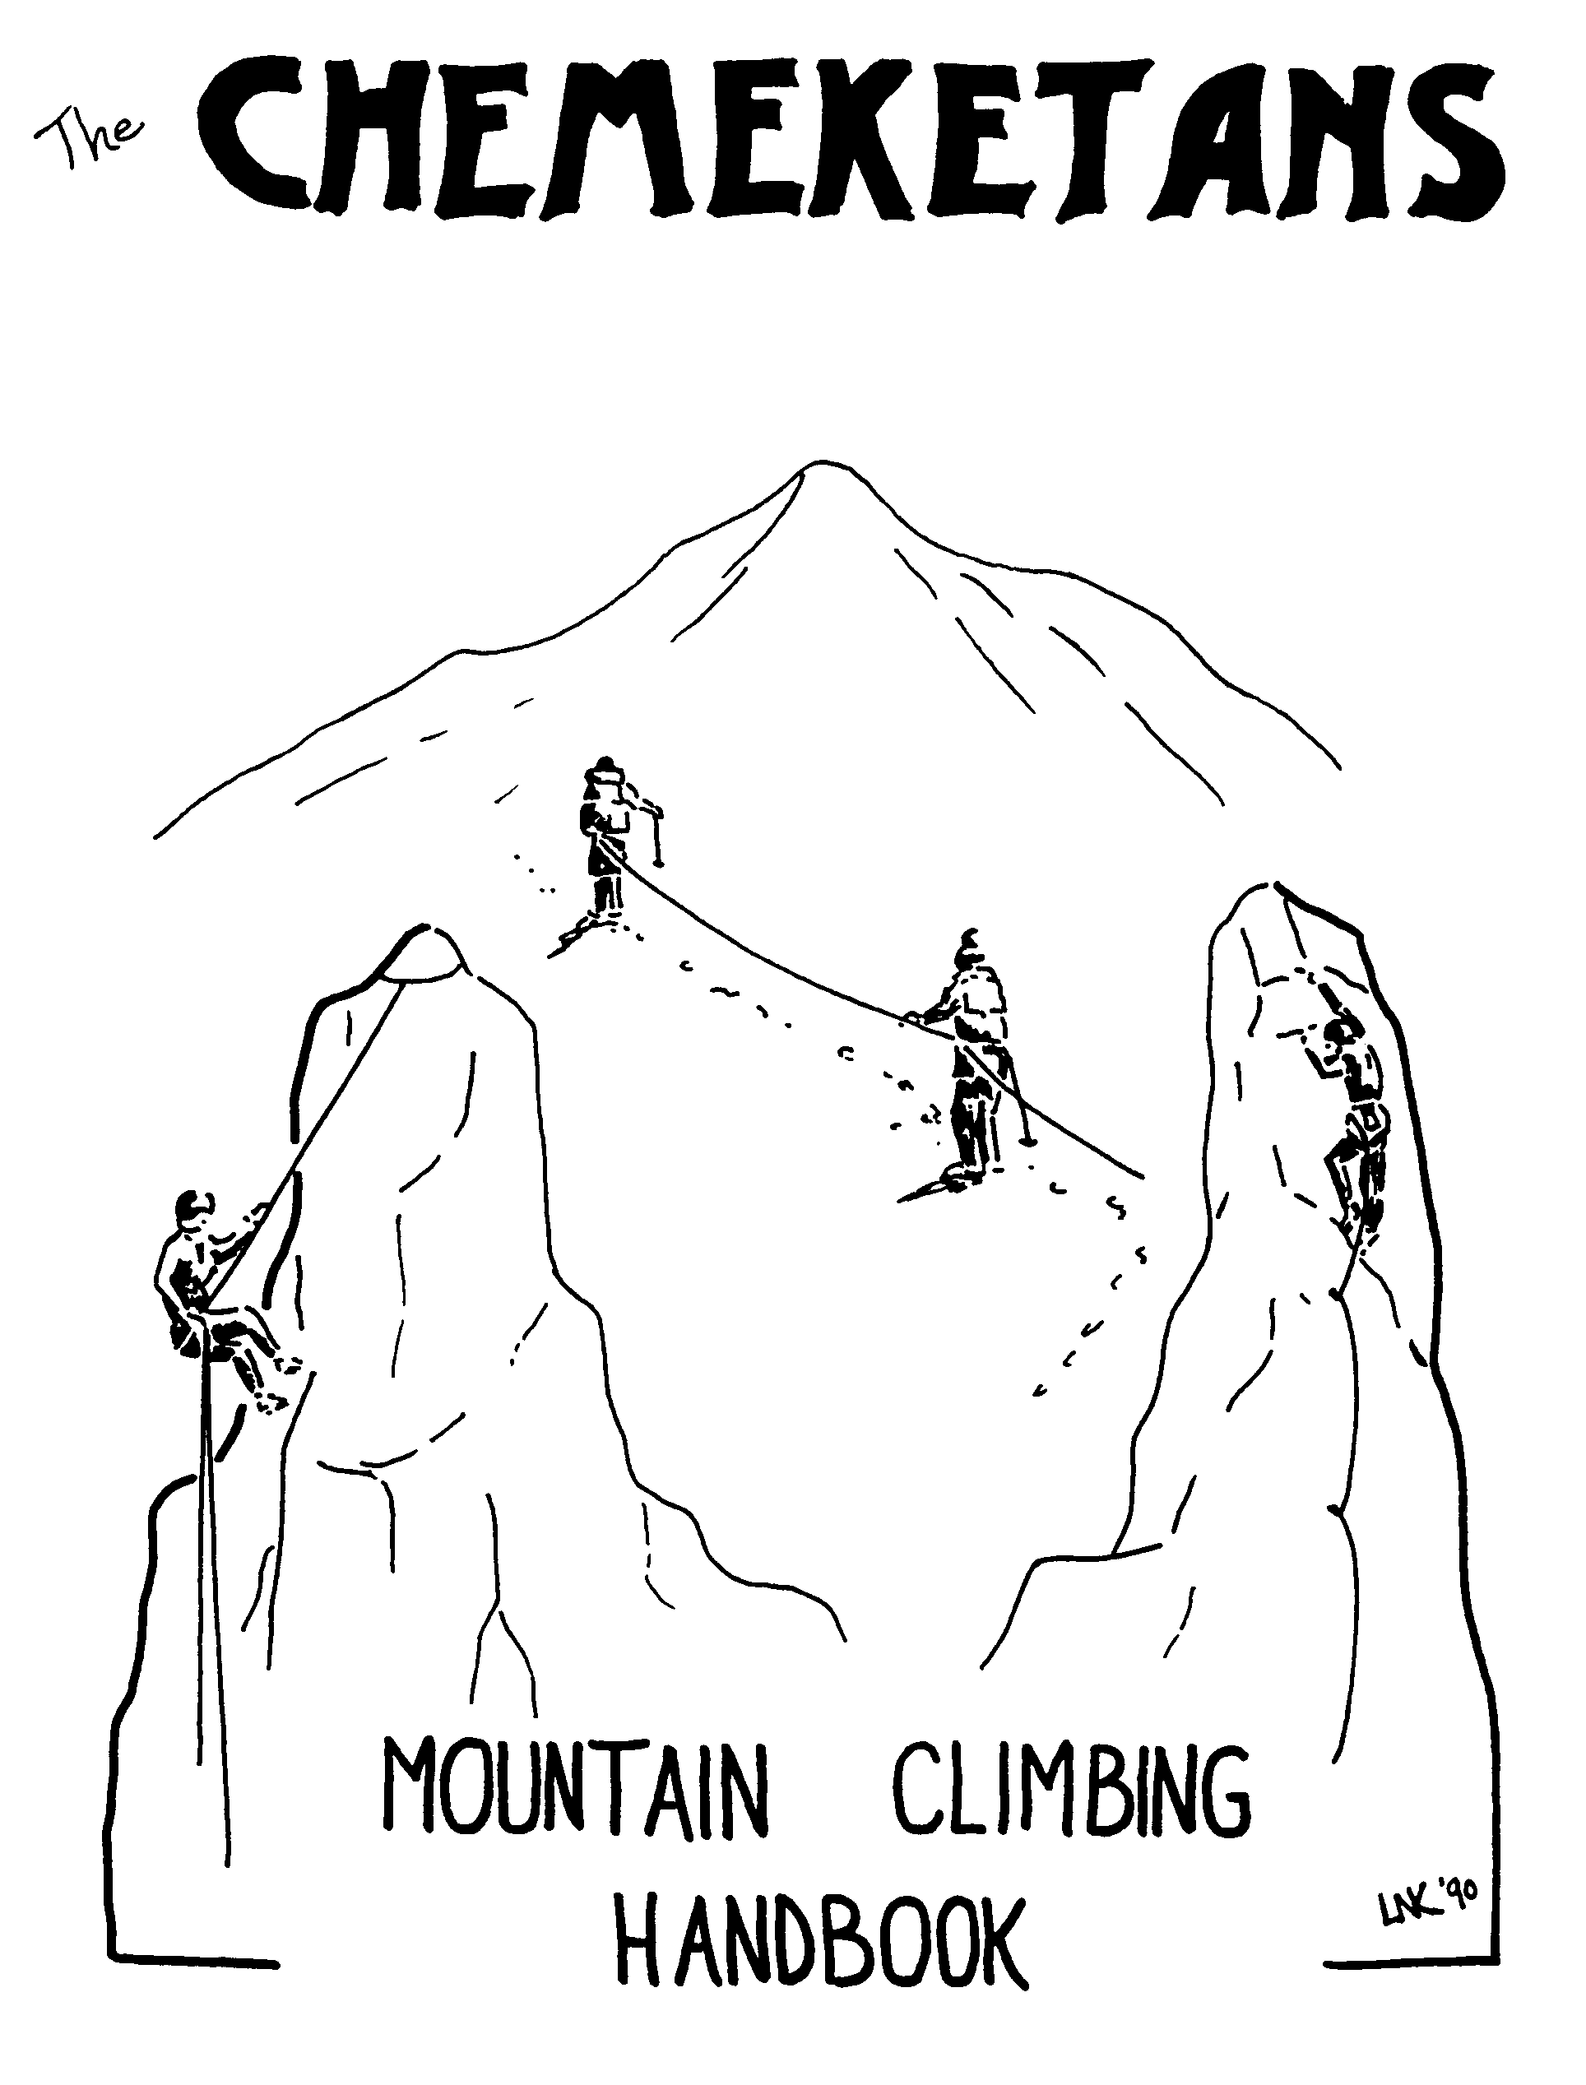

Table of Contents
Table of Contents 1
Chemeketan Climb School 2
Chemeketan Route Finding School 2
Membership Information 3
Chemeketan Climbing Program 4
Chemeketan Climbing Awards 4
Chemeketan Climbing Classification System 5
2007 Chemeketan Climb Schedule 6
Chemeketan Climb Leaders 8
Chemeketan Climb School Itinerary 9
Chemeketan Climb School Checklist 10
Horsethief Butte Map 11
Recommended Equipment for Snow Climbs 12
Recommended Equipment for Alpine Rock Climbs 13
Mountaineering Fitness 14
Hypothermia 15
Liquid, Food and Energy 17
Climbing Knots 19
Tying a Seat Harness with 22’ of 1” Tubular Webbing 20
Belaying 21
The Belaying Action 22
Climbing Signals 23
Sitting Hip Belay 24
The Boot-Ax Belay 25
Carabiner-Ice Ax Belay 25
Rappelling 26
Prusiking 27
Free Climbing 28
More Free Climbing 29
Ice Ax Self-Arrest Position 30
Crampons 31
Rope Care 32
Coiling a Rope 33
Z – Pulley Crevasse Rescue System 34
Climbing Equipment Stores 35
Notes 36

Chemeketan Climb School
Welcome to the Chemeketan Climb School. This is a basic school, during which you will learn about the equipment and techniques necessary for you to participate safely as a member of a climbing team under the leadership of an experienced climb leader. Although you are free to climb on your own after completing the climb school, we do not believe that what you learn in this school is enough to enable you to safely climb independently. Instead, we encourage you to climb during at least your first year of climbing with the Chemeketans or another climbing club, or at least with friends who are experienced (and safe) climbers. However, the choice is up to you.
The Chemeketan climb leaders are all volunteers who enjoy sharing their knowledge and love of the mountains with others. Most leaders have many years of experience climbing and leading climbs for the Chemeketans. They will do their best to teach you the basic techniques of safe climbing, and will be happy to answer any questions you may have on climbing equipment, techniques, routes, etc.
We hope that you will find the Chemeketan Climb School to be an interesting, challenging, and rewarding experience, and that you will continue to use the knowledge and skills you have learned to safely enjoy the scenic and challenging mountain environment of the Pacific Northwest.
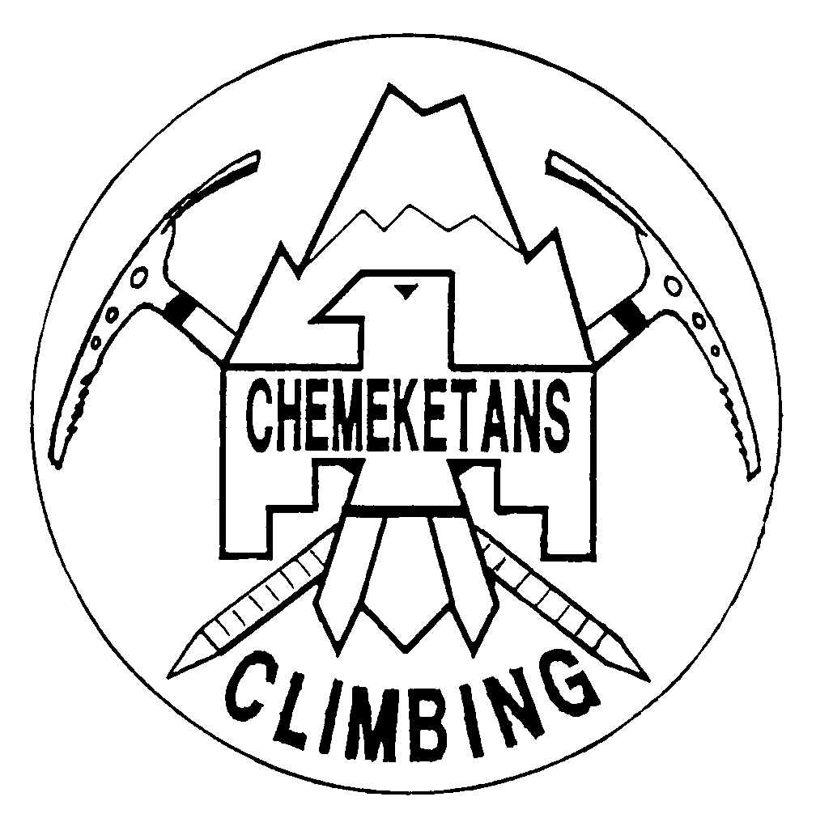

Chemeketan Route Finding School
Climb school participants may also wish to participate in this three-part series of workshops focuses on learning and practicing map, compass and GPS skills. Part one “Using Maps” is a three-hour lecture and will focus solely on revealing and understanding the enormous amount of information available in a topographical map. Parts two and three will focus on compass and GPS skills respectively. Both will consist of equal parts lecture and field session practice. Field sessions will be held within walking distance of the Chemeketan Club Room at Salem’s Riverfront Park. Participants are expected to bring their own compass, but need not own their own GPS. Participants who do not own a GPS receiver will be partnered with someone who does. Space is limited to 50 participants. Cost is $15 for Chemeketan members and $35 for non-members. You may sign-up in advance at www.cascadeadventures.net.

Membership Information

Benefits: Members receive The Chemeketan, our monthly bulletin, a prospectus of yearly activities, and a membership roster. Members vote for candidates for the Chemeketan Council. Members may also vote at the annual meeting or other special meetings. Members may rent the Chemeketan cabin and pay less for using it on scheduled trips. Members pay substantially less to attend the Annual Outing.

Membership Application: Climb school students who are not already club members paid a membership fee as part of their Chemeketan Climb School registration fee. Membership in the club is contingent on the completion of two “qualifiers”. Your successful completion of the Chemeketan Climb School will satisfy both “qualifier” requirements. Normally, application for membership is made after completing the “qualifiers”. However, in this special situation, the membership secretary will circulate membership applications during the first class room session, so that students can complete the membership application in advance. Those students who do not successfully complete the Chemeketan Climb School may still pursue membership in the club, by completing two qualifying hikes and applying for membership before October 1. The application fee, paid by nonmembers as part of their climb school registration, is not refundable or transferable and may only be used for the current year’s membership.

Dues: Annual membership dues are $14 for each adult, $3 for each junior member, plus a $12 per household subscription fee for the monthly bulletin. New members pay an additional $5 initiation fee.

Monthly Bulletin: The Chemeketan, our monthly bulletin, is a compilation of activities for the month, future events, news, trip reports, and executive council meeting reports. Items for the bulletin may be mailed to: Chemeketan Bulletin Editor, PO Box 864, Salem OR 97309.

Junior Members: Any person of any age may become a member. Persons under 18 years of age, however, are Junior Members. Junior Members have the advantage of paying less but they do not have voting rights. They enjoy all the other benefits of membership.

Membership Information: For more information about membership contact the Membership Secretary: The Chemeketans, Membership Secretary, PO Box 864, Salem OR 97308.

Chemeketan Climbing Program
The Chemeketan climbing program provides a variety of activities, training, and climbs ranging from those suitable for first year climbers to more technical climbs for experienced mountaineers. All climbs on the schedule, including the climb school, are qualifying trips for Chemeketan membership. Completion of the Chemeketan climb school, or an equivalent climb school experience as approved by the leader of each individual climb, is required for participation in Chemeketan climbs.
Chemeketan climbs are limited in party size. All wilderness area activities are limited to no more than 12 by the Forest Service. Climbers interested in a particular climb should contact the leader as soon as possible to sign up in advance of the climb. Details of Chemeketan climbs are provided in the monthly bulletin prior to a scheduled climb and on the club’s website www.chemeketans.org. Contact the individual climb leaders for more information.

Chemeketan Climbing Awards
The purpose of the Chemeketan climbing award system is to recognize those members possessed of the stamina, will power, and enterprise necessary to climb to the top of a difficult mountain.
Awards are given on request for certain climbs, as follows:
First Ascent: A climber’s first ascent of any Chemeketan award peak.
Santiam Peaks Award: Mt. Jefferson, Three Finger Jack, and Mt. Washington.
Guardian Peaks Award: Mt. Hood, Mt. St. Helens, and Mt. Adams.
Nine Oregon Peaks Award: Mt. Hood, Mt. Jefferson, Three Fingered Jack, Mt. Washington, North, Middle and South Sisters, Broken Top, and Mt. Thielsen.
Eighteen Northwest Peaks Award: The nine Oregon Cascade Peaks plus Mt. Shasta, Mt. St. Helens, Mt. Adams, Mt. Rainier, Mt. Stuart, Mt. Olympus, Glacier Peak, Mt. Baker, and Mt. Shuksan.
A member wishing to receive a Chemeketan climbing award must apply to the Climbing Committee Chair and must submit proofs of climbs such as summit certificates or Club Bulletin listings.
All climbs applied toward a Chemeketan climbing award must be scheduled Chemeketan climbs except for the 18 Peak Award for which up to six of the climbs may be made under the auspices of a fellow Federation of Western Outdoor Clubs (FWOC) member club.
A distinctive plaque shall be awarded to members who have climbed the designated 18 Northwest Peaks.
Emblem Recognition/Selected Peak and Route Lists: For those club members wishing to strive for a goal beyond the standard ones listed above, the climb leadership has devised several challenging climb lists. Each has a specific theme and level of difficulty. Special emblems may be requested upon successful completion of a climb list. See the club’s website for details.

Chemeketan Climbing Classification System
Each climb on the Chemeketan climb schedule is rated according to type and difficulty. For example, a climb rated S-1 would be a relatively easy snow climb (e.g. Mt. Hood, South Side); R-2 would be a fairly difficult rock climb (e.g. Mt. Washington, West Ridge); and M-3 would be a difficult mixed climb (e.g. Mt. Shuksan, North Face).

Type | Description
Snow  (S) | Primarily a snow climb, usually involving moderate to steep snow and crevassed glaciers where use of an ice axe and crampons are necessary.
Rock  (R) | Primarily a rock climb where climbers are placed on belay or use a fixed line. Rappelling may also be necessary.
Mixed  (M) | A mixed rock and snow climb in which both rock and snow are likely to be encountered during the climb. Knowledge and techniques applicable to both types of climbing are required.
Unrated  (U) | No technical climbing skills are required. However, it is still considered a climb since participants must travel above tree line where off-trail navigation is necessary (e.g. South Sister, south side route in summer conditions).

Difficulty | Minimum Eligibility Requirements
Level 1 | Chemeketan Climb School or equivalent (Mazama Basic Climb School, Mountaineers, Rainier Mountaineering, Inc., Santiam Alpine Club, etc.)
Level 2 | Chemeketan Climb School or equivalent and successful completion of a level 1 difficulty climb of the same type (Snow, Rock or Mixed).
Level 3 | The individual climb leader will determine the level of climbing skill and judgment required for a route of this level of difficulty.

2007 Chemeketan Climb Schedule
The Climb Schedule is subject to change. The most up to date schedule is available on the Chemeketan web site at www.chemeketans.org. Contact the Leader directly to secure a space on a climb as party size is normally limited. Details of Chemeketan activities and climbs are provided in the monthly club bulletin prior to the event. Items available to first year climbers are marked with an asterisk.

Date(s) Day(s) Description (Rating) Leader
Apr 4 Wed Climb School Classroom Session #1 @ the Den* S Dougherty
Apr 11 Wed Climb School Classroom Session #2 @ the Den* S Dougherty
Apr 13 Fri Rock Leader Protection and Anchor Building V Dunn
Skills Sessions, R1 (Prospectus)
Apr 14 Sat Climb School Rock Skills - Horsethief Butte WA* S Dougherty
Apr 15 Sun Climb School Snow Skills - Mt Hood OR* S Dougherty
Apr 19-22 Thu-Sun Mt Rainier, Ingraham Direct, S2 J Avery
Apr 22 Sun Mary's Peak Mountain Fitness Hike* S Dougherty
Apr 28-29 Sat-Sun Introduction to Smith Rock, R1* S Dougherty
Apr 28 or 29 Sat-Sun Mt Hood, South Side, S1* (K. Richardson SL) S Phillips
May TBA TBA North Twin Sister, West Ridge, M2 H Kutuk
May 5 or 6 Sat-Sun Mt Hood, Leuthold Couloir, S2 ( J Avery SL) S Phillips
May 5 or 6 Sat-Sun Mt Hood, Wy'east S2 (M. Van Campen SL) J Rudy
May 12-13 Sat-Sun Mt Hood, South Side, S1* (S Dougherty SL) K Hill
May 16 Wed Sport Climbing Seminar-Classroom Session S Phillips
at the Den, R1* (K Garlinghouse SL)
May 19-20 Sun Sport Climbing Seminar-Field Session S Phillips
at Smith Rock, R1* (K Garlinghouse SL)
May 25-27 Fri-Sun Mt Shasta, West Face S2 (H Fecker SL) J Rudy
May 26-28 Sat-Mon Mt Baker, Boulder Cleaver, S2 (B Saur SL) S Phillips
May 26-28 Sat-Mon Mt Baker, Easton Glacier, S1* S Dougherty
May 27-28 Sun-Mon South Sister, South Side w/ snow camp, S1* J Petrie
Jun TBA TBA Silver Star, Silver Star Glacier, M1* (B Saur SL) K Hill
Jun TBA TBA Black Pk, South Ridge, R1*, (B Saur SL) K Hill
Jun 2 Sat Mt Hood, South Side, S1*, (SL TBA Leader Asst) R Barry
Jun 16-17 Sat-Sun Colchuck / Dragontail, Colchuck Glacier, M2 (V Dunn SL) S Phillips
Jun 15-17 Fri-Sun Mt Baker, Coleman Upper Deming, S1* (J. Avery SL J Rudy
Jun 30-Jul 1 Sat-Sun Middle Sister, N Ridge via Hayden Glacier, S1* (SL TBA) R Barry
Jun 30-Jul 1 Sat-Sun Mt Adams, Mazama Glacier, S2* (J Avery SL) K Hill
Jul TBA TBA West McMillan Spire, West Ridge, M2 H Kutuk
Jul TBA TBA Mt Jefferson, Whitewater Glacier S2 J Petrie
M Van Campen
Jul TBA TBA Mt Washington, North Ridge, R1* (E Gradison SL S Phillips
Jul TBA TBA Mt Adams, South Side, S1* M Van Campen
Jul 5-8 Thu-Sun Mt Rainier, Disappointment Cleaver, S2 J Petrie
Jul 12-15 Thu-Sun Glacier Peak, Frostbite Ridge, S2 B Saur
Jul 14-15 Sat-Sun Mt Adams, Mazama Glacier, S2 (K. Richardson SL) R Barry
Jul 27-29 Fri-Sun Glacier Peak, Sitkum Glacier, S2* (S Dougherty SL) K Hill
Jul 28-Aug 4 Sat-Sat Northern Pickets: Mt Challenger, Challenger Glacier; B Saur
Luna Pk, SW Ridge; Mt Fury, East Ridge, M3
Aug TBA TBA Mt Washington, North Ridge, R1* (Vancampen SL) R Barry
Aug TBA TBA Three Fingered Jack, South Ridge, R1* (J. Avery SL) S Phillips
Aug TBA TBA North Sister, SE Ridge, R2 J Petrie
M Van Campen
Aug 4-5 Sat-Sun Three Fingered Jack, South Ridge, R1* S Dougherty
Aug 11-12 Sat-Sun Mt Thielsen, West Ridge, R1* (SL TBA) J Rudy
Aug 11-12 Sat-Sun North Sister, SW Ridge, R2 (J. Avery SL) R Barry
Aug 18-19 Sat-Sun Mt Washington, North Ridge, R1* S Dougherty
Aug 24-26 Fri-Sun Jack Mt, north ridge, M2 B Saur
Aug 25-26 Sat-Sun Mt Adams, South Side, S1* S Dougherty

Date(s) Day(s) Description (Rating) Leader
Sep TBA TBA Mt Thielsen, West Ridge, R1*, (SL TBA) K Hill
Sep 1-2 Sat-Sun Ingalls Peak, S. Ridge, S2 (SL TBA) J Rudy
Sep 1-3 Sat-Mon Mt Jefferson, South Ridge, M2 S Dougherty
Sep 1-3 Sat-Mon South Sister & Broken Top from Green Lakes, R1 M Van Campen
Sep 19-23 Wed-Sun Pasayten Scramblefest: Osceola Pk, Mt Lago, Blackcap Mt, B Saur
Lost Pk, Lake Mt, Monument Pk. R1*
Sep 22 Sat Mt Washington, North Ridge, R1* J Rudy
Sep 22-23 Sat-Sun Eliot Glacier Ice School (Mt Hood)* S Dougherty
Oct 6-7 Sat-Sun South Sister, Summit Camp, South Ridge, S1* P Otley
Nov TBA Sat Climbers Potluck/Slideshow (Silverton) K Garlinghouse

The Chemeketans is an outdoor recreation club, not a mountain guide service. Chemeketan climb leaders and assistants are climb facilitators, helping to organize and lead climbs, not climbing guides with appropriate certifications and professional liability insurance.
Climb participants should:
- Reserve their judgment and climb in an alert and questioning manner, not blindly placing their faith in the judgment of the leader and assistants.
- Ask questions when they do not understand what is going on.
- Notify the leader if they feel unsafe and require a belay or if they feel the climb is too dangerous for them to continue.
- Climb as a team recognizing that there is safety in numbers. Participants are expected to stop at all trail junctions and allow stragglers to regroup before proceeding.
Climb participants must sign a liability waiver whereby they:
- Agree to assume all risks associated with the activity including travel to and from the activity.
- Understand that Chemeketan climbs are potentially dangerous activities and that accidents or illness can and do occur in remote locations where access to qualified emergency medical personnel is not readily available.
- Agree to pay for their own medical and/or rescue expenses, whether or not authorized by the participant in the event of accident or illness.

Chemeketan Climb Leaders
Climbing Leaders
Avery, Jay (2005) jaydavery@comcast.net
Brownlee, Bill (1981) bbrownlee@co.marion.or.us
Dougherty, Steve (1999) stevedougherty@comcast.net
Dunn, Vincent (2000) vincentkdunn@yahoo.com
Fecker, Herb (2002) herbert63@qwest.net
Garlinghouse, Keith kgarlinghouse@cityofsalem.net
Gradison, Ellen (2003) orlawctr@peak.org
Kraschel, Kirk (Snow-2006) kirkoregon@yahoo.com
Otley, Pam pamo@osubookstore.com
Petrie, John (2006) jpetrie@sgopro.com
Richardson, Kris (2003) castilla13@aol.com
Saur, Bill (1990) wlsaur@msn.com
Stump, Tammee (1991) tammees@truittbros.com
Van Campen, Matt (2006) m.vancampen@comcast.net
Provisional Leaders
Barry, Rick (2006) rbarry67@msn.com
Braasch, Kim (2001) kimmyb@wvi.com
Hill, Keith (2006) keithhill@earthlink.net
Kraschel, Kirk (Rock-2005) kirkoregon@yahoo.com
Kutuk, Haydar (2004) haydar_kutuk@yahoo.com
Rudy, Jim (2002) jimrudy1970@yahoo.com
Rudy, Mike (2001) michaelRNclimber@yahoo.com
Assistant Leaders
Clark, Sally (2002) salclark@hotmail.com
Coyier, John (2006) jcoyer@peaksky.com
Croft, Jerry jcroft@open.org
Ellis, Jon (2006) jonandvickie@comcast.net
Gonzalez, Stefan (2000) stefan_gonzalez@hotmail.com
Good, Ryan (2005) goodsterman@yahoo.com
Kelley, Scott (2005) scotto2005@earthlink.net
Mack, Roland (2001) mackfamily@earthlink.net
Marsh, Debra (2000) damarsh2@yahoo.com
McClellan, Paul paulm@bendcable.com
Niemeyer, Mike (2005) mwniemeyer@verizon.net
Nelson, Sue (2001) susanels@juno.com
Palacios, Jess (2006) jessraidernation@netzero.net
Petrie, Gloria (2005) gpetrie@ascensionaccounting.com
Petrin, JP (2001) skired1@comcast.net
Phillips, Greg (2006) gregoryallenp@hotmail.com
Phillips, Scott (2001) climbingscott@comcast.net
Smith, Robyn (2005) robins@maytrucking.com
Smith, Tim (2005) pino1973@yahoo.com
Tedrow, Brad (2001) bcdht@proaxis.com
Tedrow, Greg (2005) gbt@limo.net
Tschanz, Jim (2003) james.w.tschanz@intel.com
Truax, Jennifer (2003) jennifer.truax@salemhospital.org

Chemeketan Climb School Itinerary

Wed. 4/4
6:30 PM – Registration, Introduction, Club Membership, Pod Assignments
6:45 PM - Climbing Slide Show
7:15 PM - Mountaineering Fitness
7:30 PM - Food for Climbing
7:50 PM - 10 min Break
8:00 PM - Equipment for a One-Day Climb
8:45 PM - Equipment for 2nd Class & Field Sessions, Homework Assignment
9:15 PM – Dismiss/Turn in Name Tags
Homework:
- Purchase and bring carabineers, webbing or harness and accessory cord to the next class session (see climb school checklist on page 10.
- Practice tying knots (see page 19).
- Review climbing signals (see page 23).

Wed. 4/11
6:00 PM - Gear Swap (student attendance is optional)
6:30 PM - Video: "Basic Technique: Alpine Mountaineering on Mt. Rainier" (52 min)
7:25 PM - Video Debrief
7:30 PM - 10 min Break
7:40 PM - Field Sessions Logistics, Transportation and Introduction to Skills
8:15 PM – Harness and Mountaineering Knot Practice – Pod Leaders
9:15 PM – Dismiss/Turn in Name Tags

Sat. 4/14
5:30 AM - Meet at State Motor Pool Park and Ride on Airport Rd. between State St. and Mission Ave.
7:00 AM - Rest Stop … Flying J Truck Stop in Troutdale, Exit 17 Marine Dr/Troutdale.
8:30 AM - Hike into climbing area at Horsethief Butte.
9:00 AM - Begin Rock Climbing Skill Stations
5:00 PM - Load Vans – Drive to Spearfish Campground and set up tents.
6:00 PM - Drive to The Dalles for a catered buffet. Cost included in registration. Cost for assistant leaders and helpers is $10. Pizza, pasta & salad bar buffet at Spookies Pizza, 541-298-2211.

Sun. 4/15
6:00 AM - Load Vans – Drive to Timberline Lodge.
9:00 AM - Snow Climbing skills practice.
3:00 PM - Meet in the WyEast Day Lodge for awarding of climb school certificates and debriefing.
4:00 PM - Drive to Salem.
6:00 PM - Arrive at State Motor Pool Park and Ride in Salem.

Chemeketan Climb School Checklist

Water
- Sat-2 quarts in field, 1 quart in van
- Sun-1 quart in field, 1 quart in van

Food
- Sat-lunch, sack lunch, large
- Sat-dinner, Spookies Pizza
- Sun-breakfast, McDonalds
- Sun-lunch, sack lunch, large
- Sun-snack for drive home

Saturday Clothing
- long sleeve shirt
- loose-fitting long pants (jeans OK)
- lug soled boots or tennis shoes
- hat, sun
- jacket, warm synthetic
- hat, warm
- rain gear

Sunday Clothing
- boots, waterproof
- gaiters (optional)
- gloves or mittens, warm & spares
- hat, sun
- hat, warm
- jacket, rain
- jacket, warm synthetic
- long underwear (e.g. polypro)
- long sleeve undershirt (e.g. polypro)
- nylon shorts (optional)
- pants, rain
- pants, warm wool or fleece
- socks, liner & spares
- socks, thick wool & spares
- sweater, wool or fleece

Climbing
- carabiner, oval
- carabiner, locking
- helmet
- ice axe
- pack
- prusik slings (5' and 15' of 5-6mm Perlon)
- rock climbing shoes (optional)
- seat harness or 22 ft. of 1in. tubular webbing
- sit pad, ensolite (optional)

Handy Bag
- camera (optional)
- chap stick (optional)
- duct tape
- first aid kit
- handkerchief
- head lamp/extra battery & bulb
- pocket knife
- sunglasses/sunscreen
- tissue paper

Camping
- sleeping bag
- sleeping pad
- tent (shared)

Miscellaneous
- Oregon Sno-Park Permit ($15/yr), if you are driving your own vehicle.

Horsethief Butte Map

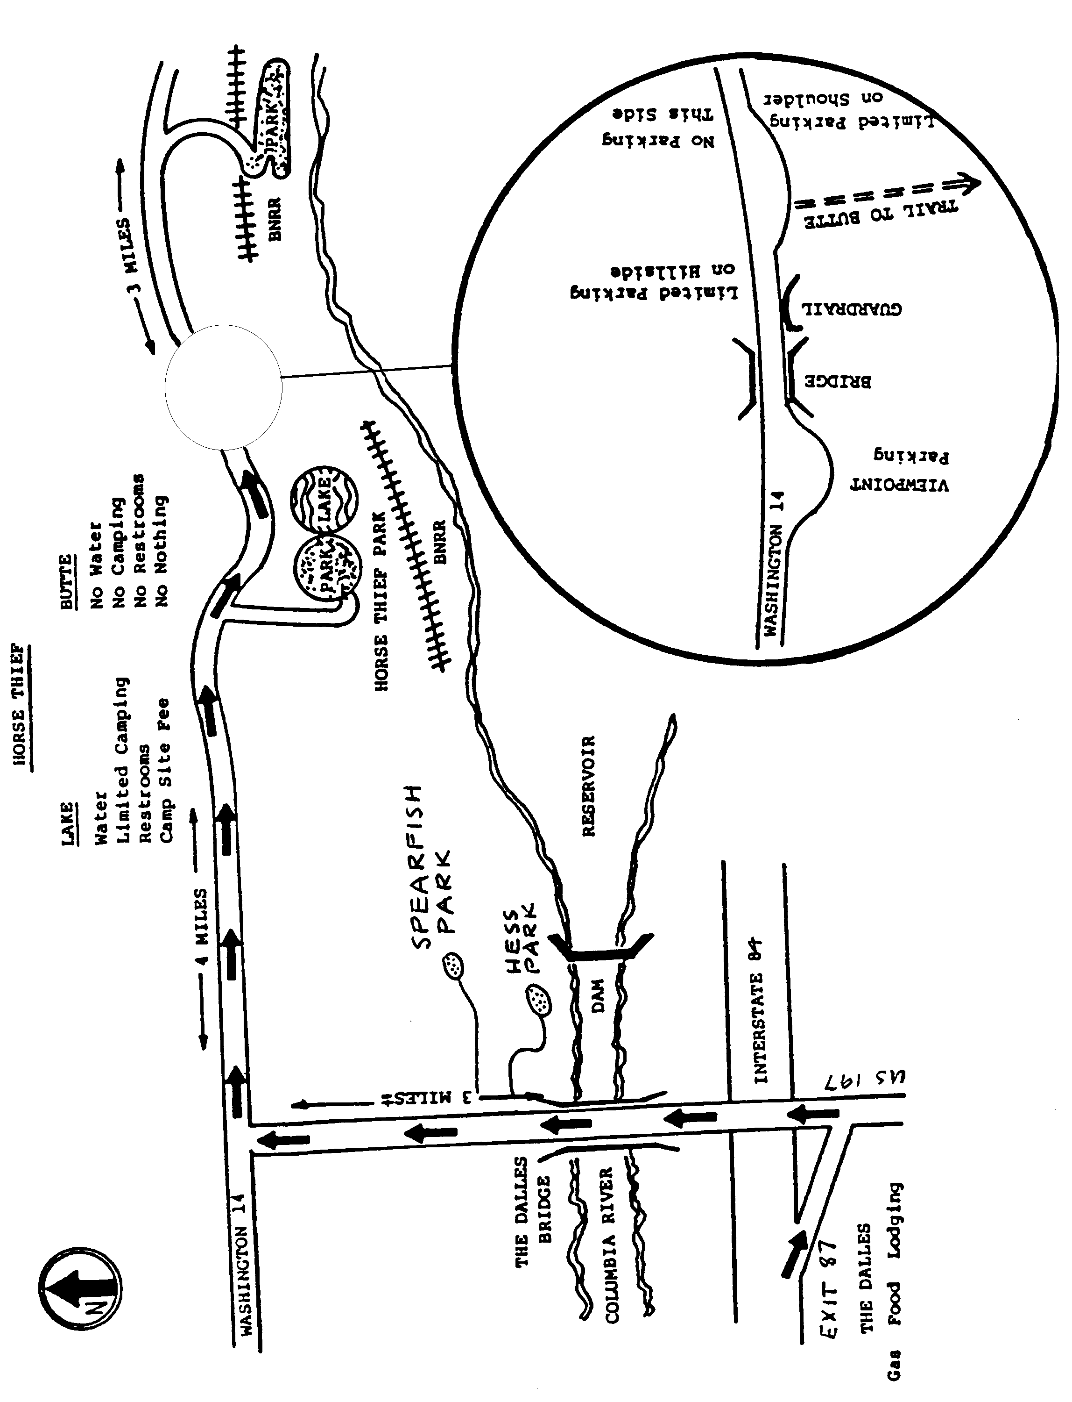

Recommended Equipment for Snow Climbs

Water & Water
- wide mouth bottles, quart size, 2
- food for full day that can be eaten in short stops
- extra food

Clothing
- boots, heavy leather or plastic
- gaiters
- gloves or mittens, warm
- fleece gloves
- hat, sun, covers neck & ears
- hat, warm
- ski goggles
- jacket, waterproof breathable
- jacket, warm synthetic
- long underwear (e.g. polypro)
- long sleeve undershirt (e.g. polypro)
- nylon shorts (breathable nylon)
- pants, waterproof breathable
- pants, warm wool or fleece
- socks, liner & spares
- socks, thick wool & spares
- sweater, wool or fleece

Climbing
- carabiner, oval
- carabiner, locking
- helmet
- ice axe
- pack
- prusik slings
- harness
- crampons
- ski poles, (optional)
- sit pad, ensolite (optional)
- snow shovel
Handy Bag
- camera (optional)
- chap stick (optional)
- duct tape
- first aid kit
- handkerchief
- head lamp/extra battery & bulb
- pocket knife
- sunglasses/sunscreen
- tissue paper
- matches, waterproof
- fire starter (or candle)
- utility cord
- whistle (around neck)
- spare gloves/mittens
- watch
- altimeter (optional)
- personal medications (for 3 days)
- compass
- map

First Aid Kit
- 6 adhesive bandages (1”)
- 6 butterfly bandages
- 4 gauze pads (4” x 4”)
- 1 gauze roll (2” x 5 yd)
- non-elastic ankle wrap
- adhesive tape
- scissors
- triangular bandage
- safety pins
- aspirin or equivalent
- antacid
- moleskin

Recommended Equipment for Alpine Rock Climbs

Water & Water
- wide mouth bottles, quart size, 2
- food for full day that can be eaten in short stops
- extra food

Clothing
- boots, leather
- gaiters (optional)
- gloves or mittens, warm
- fleece gloves
- hat, sun
- hat, warm
- jacket, waterproof breathable
- jacket, warm synthetic
- long underwear (e.g. polypro)
- long sleeve undershirt (e.g. polypro)
- nylon shorts (breathable nylon)
- pants, waterproof breathable
- pants, warm wool or fleece
- socks, liner & spares
- socks, thick wool & spares
- sweater, wool or fleece

Climbing
- carabiner, oval
- carabiner, locking
- rappel/belay device (e.g. figure 8)
- helmet
- pack
- prusik slings
- harness
- rock shoes (optional)
Handy Bag
- camera (optional)
- chap stick (optional)
- duct tape
- first aid kit
- handkerchief
- head lamp/extra battery & bulb
- pocket knife
- sunglasses/sunscreen
- tissue paper
- matches, waterproof
- fire starter (or candle)
- utility cord
- whistle (around neck)
- watch
- altimeter (optional)
- personal medications (for 3 days)
- compass
- map
- mosquito repellent

First Aid Kit
- 6 adhesive bandages (1”)
- 6 butterfly bandages
- 4 gauze pads (4” x 4”)
- 1 gauze roll (2” x 5 yd)
- non-elastic ankle wrap
- adhesive tape
- scissors
- triangular bandage
- safety pins
- aspirin or equivalent
- antacid
- moleskin

Mountaineering Fitness
Let’s face it mountaineering requires excellent physical fitness. A climber in poor physical condition can jeopardize the success and even the safety of the climb team. For this reason, it is essential that all climbers adequately prepare themselves physically before participating in a Chemeketan club climb. The mountaineer needs good leg strength and great cardiovascular endurance to sustain a steady pace uphill for many hours.
How Do I Get In Shape For A Mt. Hood Climb?
To prepare your body for the physical demands of a Mt. Hood climb it is best to progress your fitness level by using a series of benchmarks or fitness goals. Even very fit people often underestimate what it takes to achieve the best training regime for mountaineering. Gaining elevation and wearing a pack are key elements to the athletic feat of mountaineering. Some fitness goals to promote a successful and positive mountaineering experience include:
- Running three miles in less than 30 minutes.
- Running at a moderate pace for 45 minutes without a break.
- Cycling 30 miles including hills in less than two hours.
- Climbing Willamette University stadium steps for 30-45 minutes at a moderate pace. Start with a ten-pound pack and working up to a 25-pound pack.
- Hike the North Ridge Trail on Mary’s Peak in under two hours with a 30-pound pack.
- Hiking the Mt, Defiance trail, in the Columbia River Gorge, to the top in under six hours with a pack weight comparable to the gear required for a Mt. Hood climb. Plan to take a break to hydrate and eat about every 45-90 minutes.
- Another measure you could use anywhere includes hiking 1,000 feet an hour on any hike with an elevation gain of at least 2,000 feet.
Specificity of Exercise – The closer your exercise matches the movements, intensity and duration of a Mt. Hood climb the better. Running, cycling, and climbing stairs are good matches for the muscles used in climbing while swimming and walking on a flat course is not. Given that it takes about seven hours of steady hiking uphill (5,000’) to reach the summit of Mt. Hood. You should do at least one long workout (two hour minimum) once a week. Ideally, this should be a long hike with lots of elevation gain carrying a pack loaded with water, food and your climbing gear.
Overload Principle – Vary the intensity or duration of your workouts. Do a very hard or very long workout at least once a week but no more than three times a week. Your body will adapt to the increased intensity or duration making you stronger. Duration is more important than intensity. If your training time is limited, increase the intensity, by going faster or carrying more weight, to overload the muscles.
Hard/Easy Principle – Do light workouts between the hard ones to give your body an opportunity to recover and get stronger. Working out hard every day invites injury and burnout.
Progressive Resistance – This doesn’t apply to just weight training. Add intensity or duration to your exercise routine gradually. Over time your body will adapt and become stronger. Train daily. Three days a week is not enough. Shoot for five or six days a week

Hypothermia

COLD KILLS IN TWO DISTINCT STEPS
    - EXPOSURE -- The moment your body begins to lose heat faster than it produces it, you are undergoing exposure. Two things happen:
- You voluntarily exercise to stay warm.
- Your body makes involuntary adjustments to preserve normal temperature in the vital organs, and you start shivering.
- Either response drains your energy reserves. The only way to stop the drain is to reduce the degree of exposure. The time to prevent hypothermia is during the period of exposure and gradual exhaustion.
    - HYPOTHERMIA -- If exposure continues until your energy reserves are exhausted:
- Cold reaches the brain depriving you of good judgment and reasoning power. You will not realize this is happening.
- You will lose control of your hands.
- This is hypothermia. Your internal temperature is sliding downward. Without treatment, this slide leads to stupor, collapse, and death.

AVOIDING EXPOSURE
  - STAY DRY. When clothes get wet, they lose about ninety percent of their insulating value. Wool loses less as does many of the new synthetics. Cotton and wet down are worthless.
  - BEWARE OF THE WIND. A slight breeze carries heat away from bare skin much faster than still air. Wind drives cold air under and through clothing. Wind refrigerates wet clothes by evaporating moisture from the surface. WIND MULTIPLIES THE PROBLEMS OF STAYING DRY. If you have been in the water and you are wearing a T-shirt that is wet remove it and you will retain more heat. Direct sunlight on the skin helps in the warming process.
    - UNDERSTANDING COLD. Most hypothermia cases develop in air temperatures between 30 and 50 degrees. Most outdoor enthusiast simply can't believe such temperatures can be dangerous. They fatally underestimate the danger of being wet at such temperatures. Fifty-degree water is unbearably cold. The cold that kills is cold water running down your neck and legs, and cold water removing body heat from the surface of your clothes.
    - TERMINATE EXPOSURE. If you cannot stay dry and warm under existing weather conditions, using the clothes you have with you, do whatever is necessary to be less exposed. Be smart enough to give up reaching the peak, or whatever you had in mind.
- Get out of the wind and rain. Build a fire. Concentrate on making your camp or bivouac as secure and comfortable as possible.
- Never ignore shivering. Persistent or violent shivering is a clear warning that you are on the verge of hypothermia.
- Make camp or get back to your vehicle.
    - BEWARE OF EXHAUSTION. Make camp while you still have a reserve of energy. Allow for the fact that exposure greatly reduces your normal endurance. You may think you are doing fine when the fact that you are exercising is the only thing preventing your going into hypothermia. If exhaustion forces you to stop moving, however brief:
- Your rate of body heat production instantly drops by fifty percent or more.
- Violent, incapacitating shivering may begin immediately.
- You may slip into hypothermia in a matter of minutes.
    - APPOINT A LEADER. Make the best protected and experienced member of your party responsible for calling a halt before the least protected member becomes exhausted or goes into violent shivering.
    - DETECT HYPOTHERMIA. If your group is exposed to WIND, COLD, OR WET, think hypothermia. Watch yourself and others for the symptoms.
- Uncontrollable fits of shivering.
- Vague, slow, slurred speech.
- Memory lapses, or incoherence.
- Immobile, fumbling hands.
- Frequent stumbling.
- Drowsiness (to sleep is to die.)
- Apparent exhaustion. Inability to get up after a rest.
    - TREATMENT
- The victim may deny he/she is in trouble. Believe the symptoms, not the person. Even mild symptoms demand immediate treatment.
- Get the victim out of the wind and rain.
- Strip off all wet clothes.
- Give him/her warm drinks. (Only small amounts)
- Get him/her into dry clothes and a warm dry sleeping bag. Well-wrapped warm water bottles or rocks placed between the thighs and under the arms will hasten recovery.
- If the patient is semi-conscious or worse:
    - Try to keep him/her awake. (Do not give hot liquids by mouth.)
    - Leave him/her stripped. Put him/her in a sleeping bag with another person (also stripped) to transfer heat. If you can, put the victim between two heat donors. Skin to skin contact is a very effective treatment.

Liquid, Food and Energy

Goals
To keep up with the group, not slowing the group to the point that safety is compromised, to summit and return feeling OK, and to carry a fair share of group equipment.

Climbing is not a time to diet, or lose weight. Don’t bring carrots, or banana bread, unless you’re fully confident the weight won’t slow you down. It’s energy we want, and lots of it. Nor is climbing the time to overeat, because of the weight of food and the need to eat easily digestible food. Stomach problems are very unpleasant while climbing.

Liquids
Dehydration produces the same symptoms as altitude sickness: First, malaise and loss of appetite, then headache, followed by increasing weakness and lessening of interest in the climb. Help to minimize the chance or severity of dehydration by pacing yourself, and drinking water often. Carry some of your water where it is readily available.

Water facilitates the metabolism of the carbohydrates you should be eating. Water or sports drink? Use what you are used to, since climbing is not the time to experiment.

Sources of water: (1) purity concerns (2) replenishing water bottle with snow. A wide mouth bottle is needed for ease in adding snow.

Quantity: Two liters for a Mt. Hood climb, carried in at least two leak proof bottles, such as Nalgene or Lexan. Dark urine or not needing to urinate in the morning means you’re not drinking enough.

Food
Running on flat ground, without a pack and heavy boots, burns 700 to 1000 calories an hour, so consider how many calories are consumed in a 12-hour climb.

Carbohydrates supply energy the quickest, but are used in two hours or less, so snack on small amounts frequently. Complex carbohydrates provide a gradual energy source, compared to plain sugar. Carry snacking food in a pocket or pouch.

Eat a mixture of carbohydrates and fat. The fat kicks in later in the day or night. Protein isn’t important on even an overnight trip. Many sources of fat contain protein anyway, e.g. peanuts, cheese. Cans of tuna, chicken, sardines, smoked oysters, etc., are too messy and smelly to be worth it. Cheese, in small sealable containers, is much cleaner. Eat a spoon full or two or three with dinner, and one or two for breakfast.

One sleeps much warmer and has more energy the next morning after eating a large dinner of carbohydrates, along with some form of fat.

Food should taste good, so you want to eat it. Climbing is a time to eat like a kid again: candy bars, chocolate, salty nuts, peanut butter and jam sandwiches, lemon drops, M&Ms, etc. Make sure some source of food provides some salt, to replace salt lost in perspiration.

Tums.

Emergency Food and Water
Emergency food should not need cooking, be lightweight, easily digestible, and store well for long periods (it hopefully stays in the bottom of your pack for many trips). It should also, ideally not be the sort of food you’d be tempted to gorge all at once, e.g. combination of jerky, nuts, granola bars, granola, and dried fruit works well. Maybe also extra cocoa, dried soup, and tea if a heat source is available to melt snow for water. A small aluminum cup is something you could melt snow in over a candle

Etiquette
Eat and drink quickly during breaks, so that you don’t hold up the group, or cause others to get cold waiting for you.

Climbing Knots
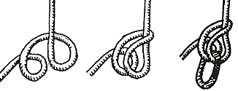
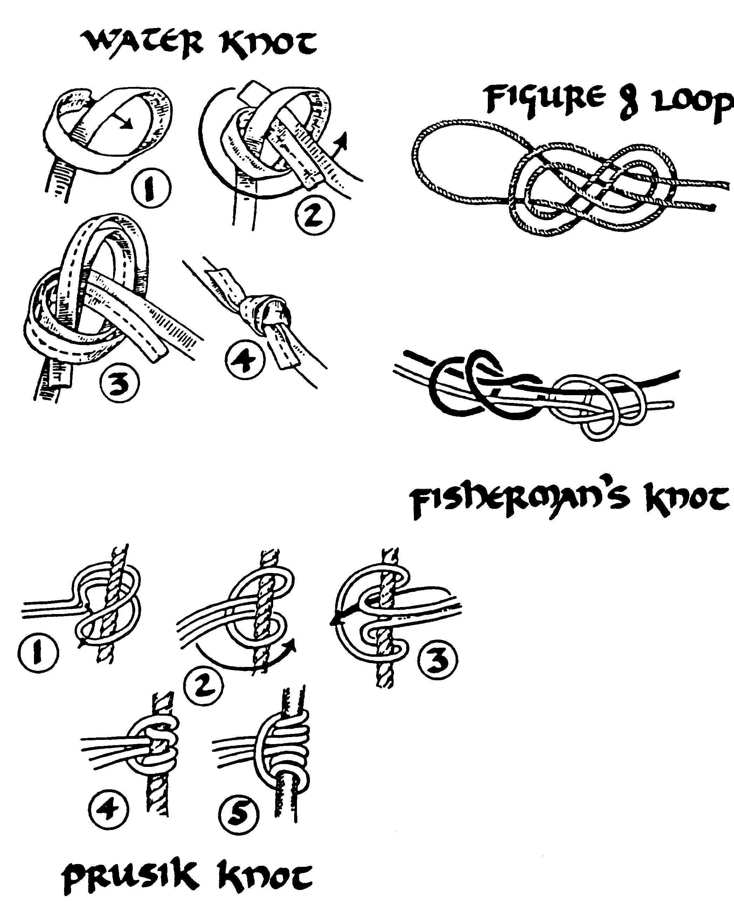

Munter Hitch

Tying a Seat Harness with 22’ of 1” Tubular Webbing

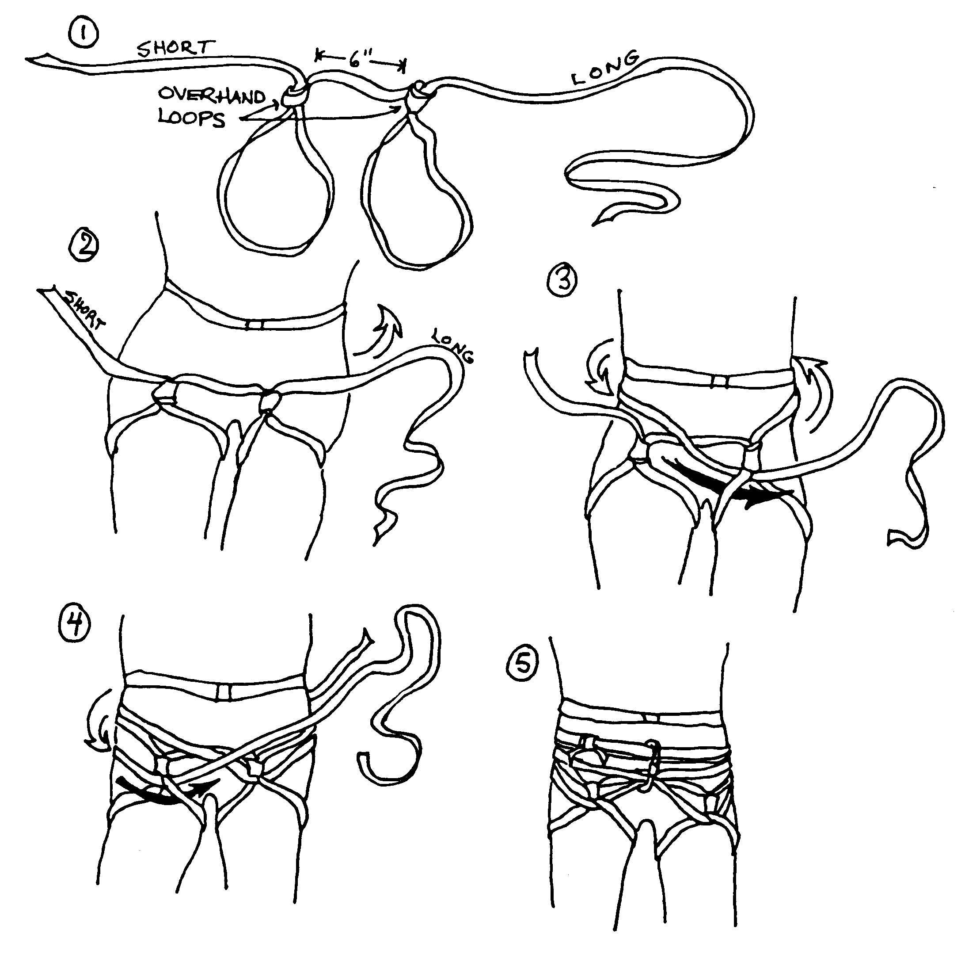

Belaying
Belaying is a vital part of the art of mountaineering. Belaying is the act of protecting a climber by another climber who is more secure. An “anchored” climber, tied to another climber by a rope, uses belay technique to stop his partner should he fall.
There are several types of belays. We use the “seated hip belay” during the Saturday field session to demonstrate the fundamentals of belaying. However, on actual climbs, leaders will use a belay device, such as a Black Diamond ATC, to increase the effectiveness of their belay.
A belay works because of the mechanical advantage of friction. Friction over the body or belay device, carabiners and rock make it possible for a belayer to withstand the several hundred pounds of force created by a falling climber.

There are several factors to be considered in setting up a belay:
- Anchor …“bombproof” rock, piton, bolt, tree, etc.
- Anchor, belayer and foot brace in line with direction of fall
- Strong position … solid foot brace with locked knees
- Comfortable position …you will be here a while
- Safe position … safe from falling rocks, climbers, etc.
- Brake hand never leaves the rope.
- Rope management … avoid slack, tangling, sharp rocks, etc.
- Use the basic voice commands
The belay position must be comfortable because some climbs involve considerable lengths of time at which the belayer must be ready to react to an emergency. The belayer who is not comfortable will tend to move around attempting to find some relief from the pain of sharp rocks, etc. While moving, even in the slightest amount, he is not ready to operate the belay. Not only must the belayer be comfortable waiting for a fall and stopping that fall, but also he may be called upon to hold a fallen climber for some time, or lower him to a place of safety.
The foot brace solidifies the position and makes it possible to keep the belayer from being pulled out of position. The foot brace and the anchor must be coordinated with the direction of fall. The components of a belay, including the belayer, must be kept in as close a line as possible. If any of these components are allowed to be out of line, the force of a fall will tend to pull that component out of its position and into the common line.

The Belaying Action

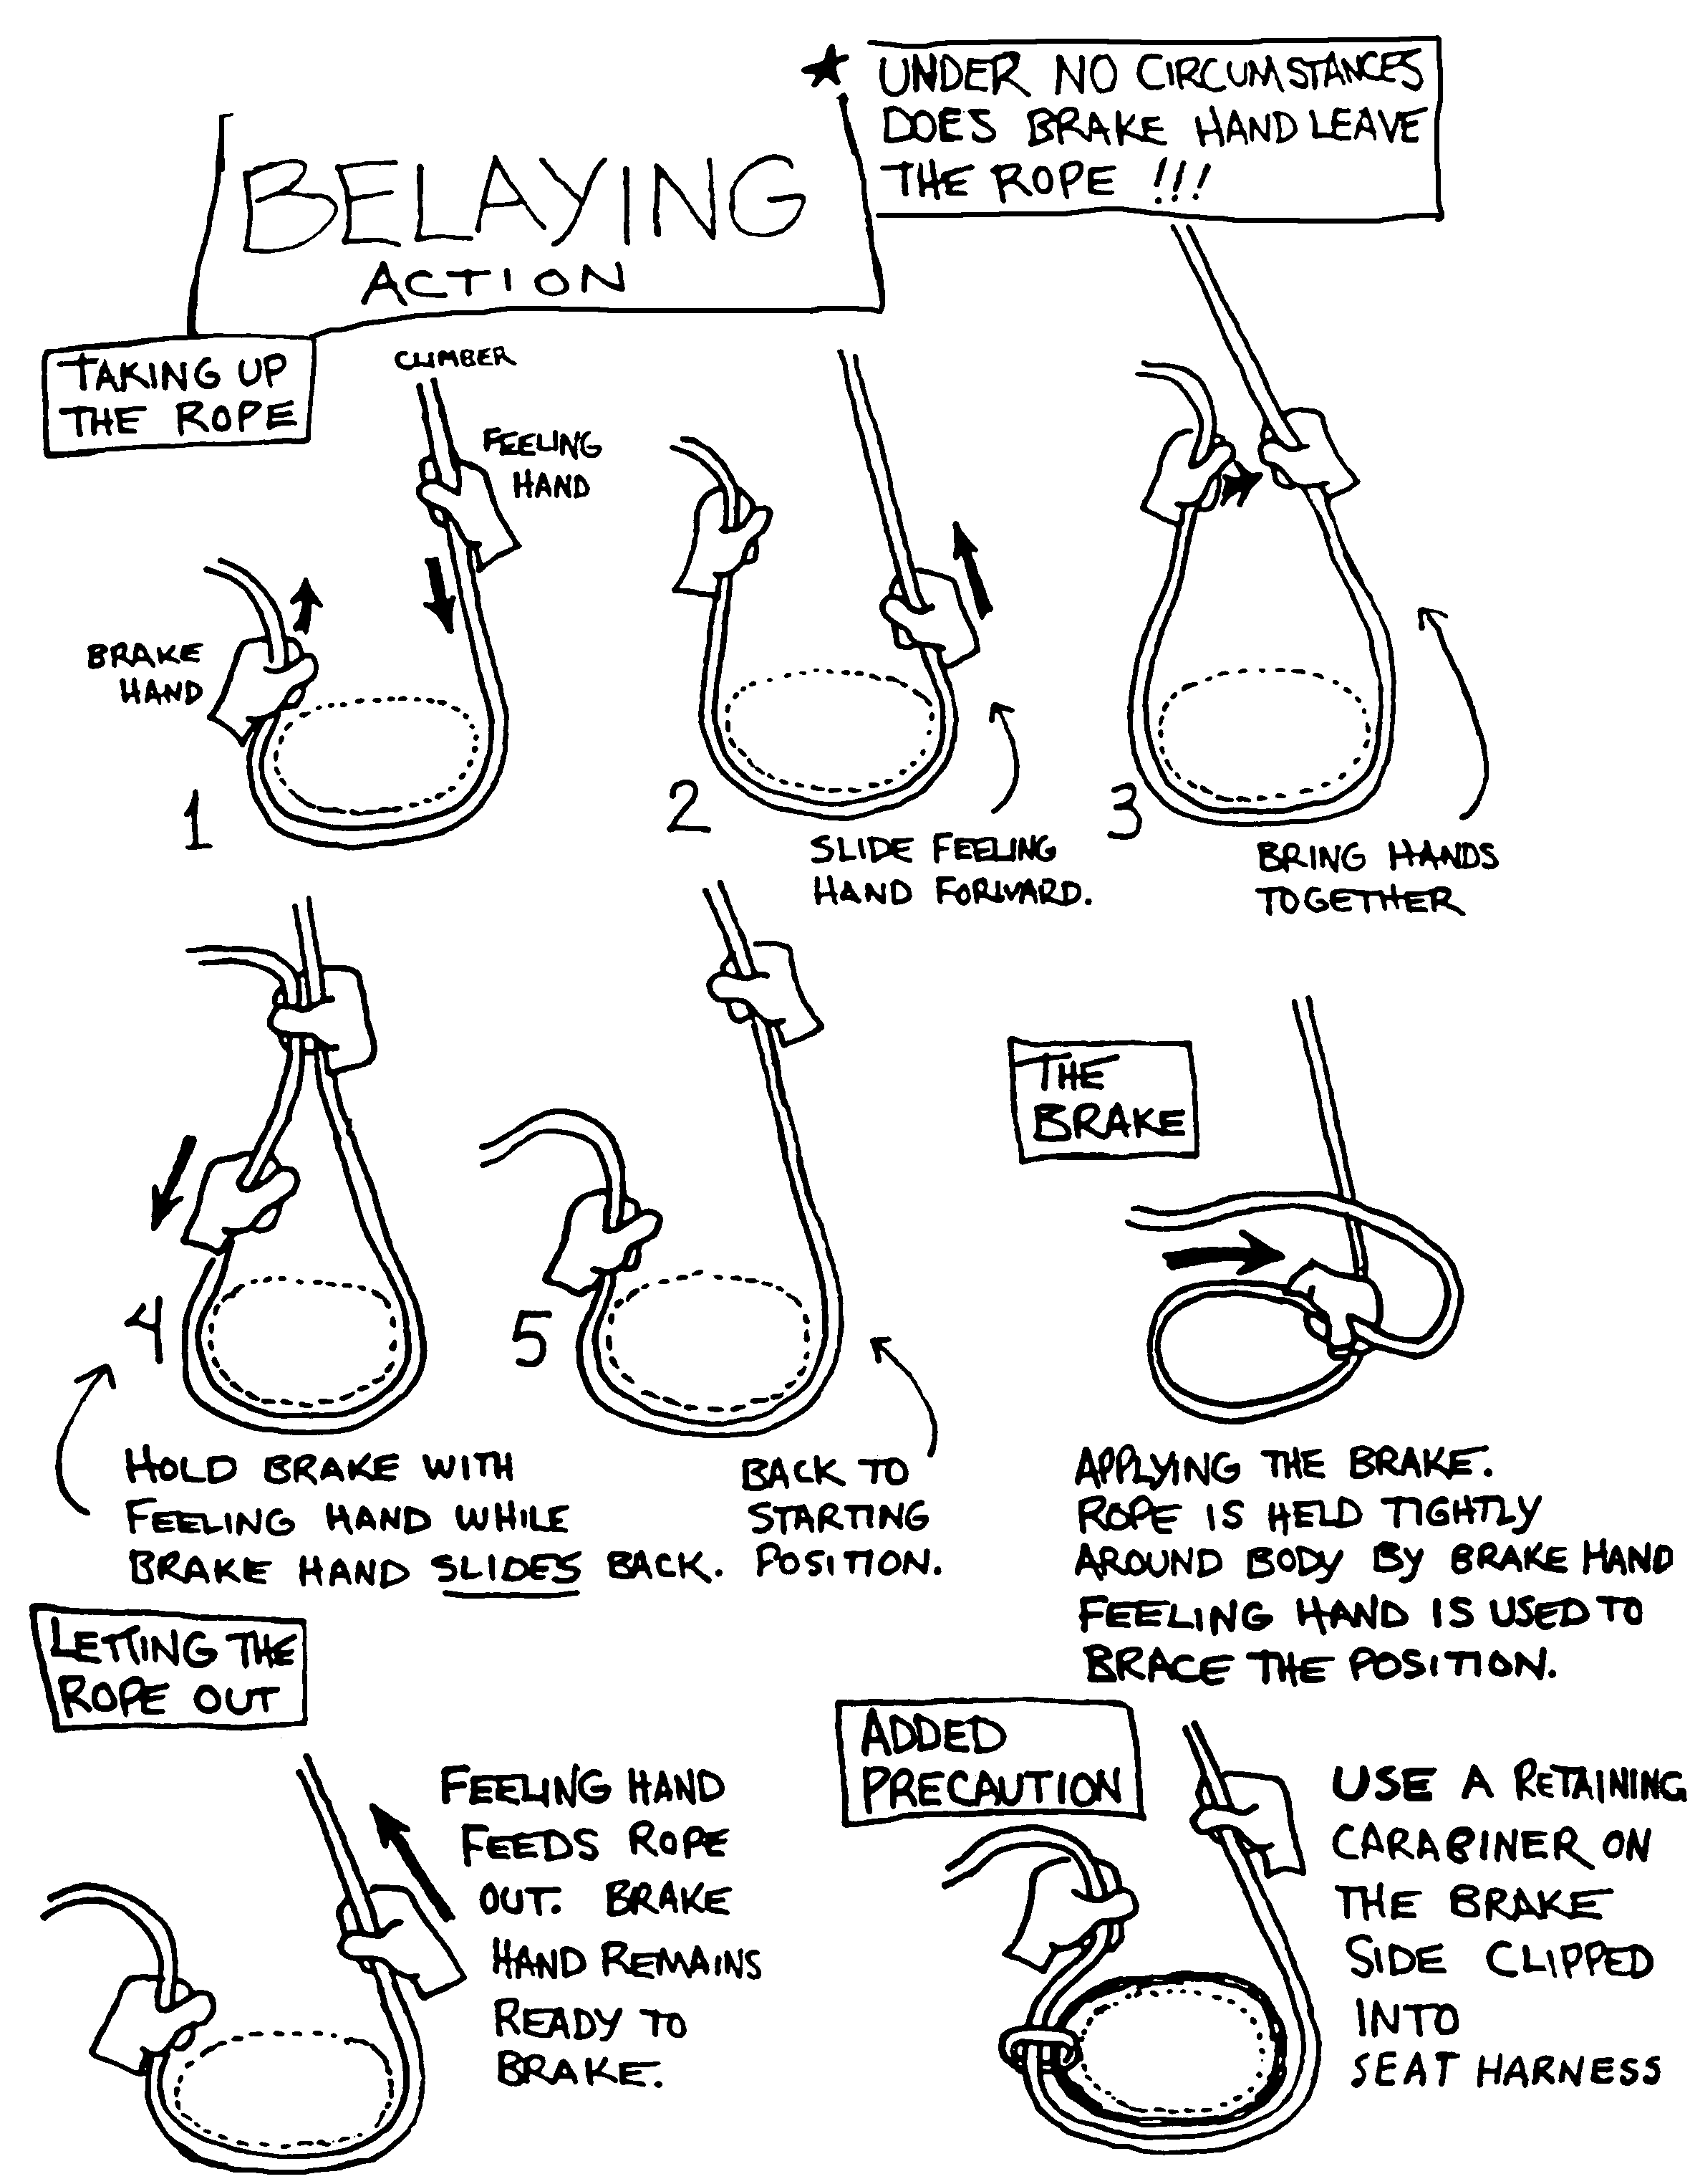

Climbing Signals

Climbing signals are specific verbal commands that allow a climber to communicate needs to the belayer. Be crisp and clear. It is often hard to hear due to windy conditions. Don't take anyone off belay unless you are sure. Use first names in crowded climbing areas. Yes, the wrong person has been taken off belay by hearing another party's calls.
On Belay – Climber to Belayer. Asked as a question … I want to go. Are you ready?
Belay On – Belayer to Climber. All set. The belay is ready.
Climbing – Climber to Belayer. Here I come.
Climb – Belayer to Climber. Come ahead.
Up Rope – Climber to Belayer. There is slack in the rope. Take up all the loose rope.
That’s Me – Climber to Belayer. You are tugging on me. There is no slack in the rope.
Slack – Climber to Belayer. I can’t move without some slack in the rope.
Tension – Climber to Belayer. Hold the rope tight.
Watch Me – Climber to Belayer. I may fall. Be ready!
Falling – Climber to Belayer. Catch me. I’m falling!
Rock – Watch out for the rock headed your way.
Off Belay – Climber to Belayer. I am in a secure position and do not need a belay.
Belay Off – Belayer to Climber. Echoed to insure there is no misunderstanding.

Sitting Hip Belay
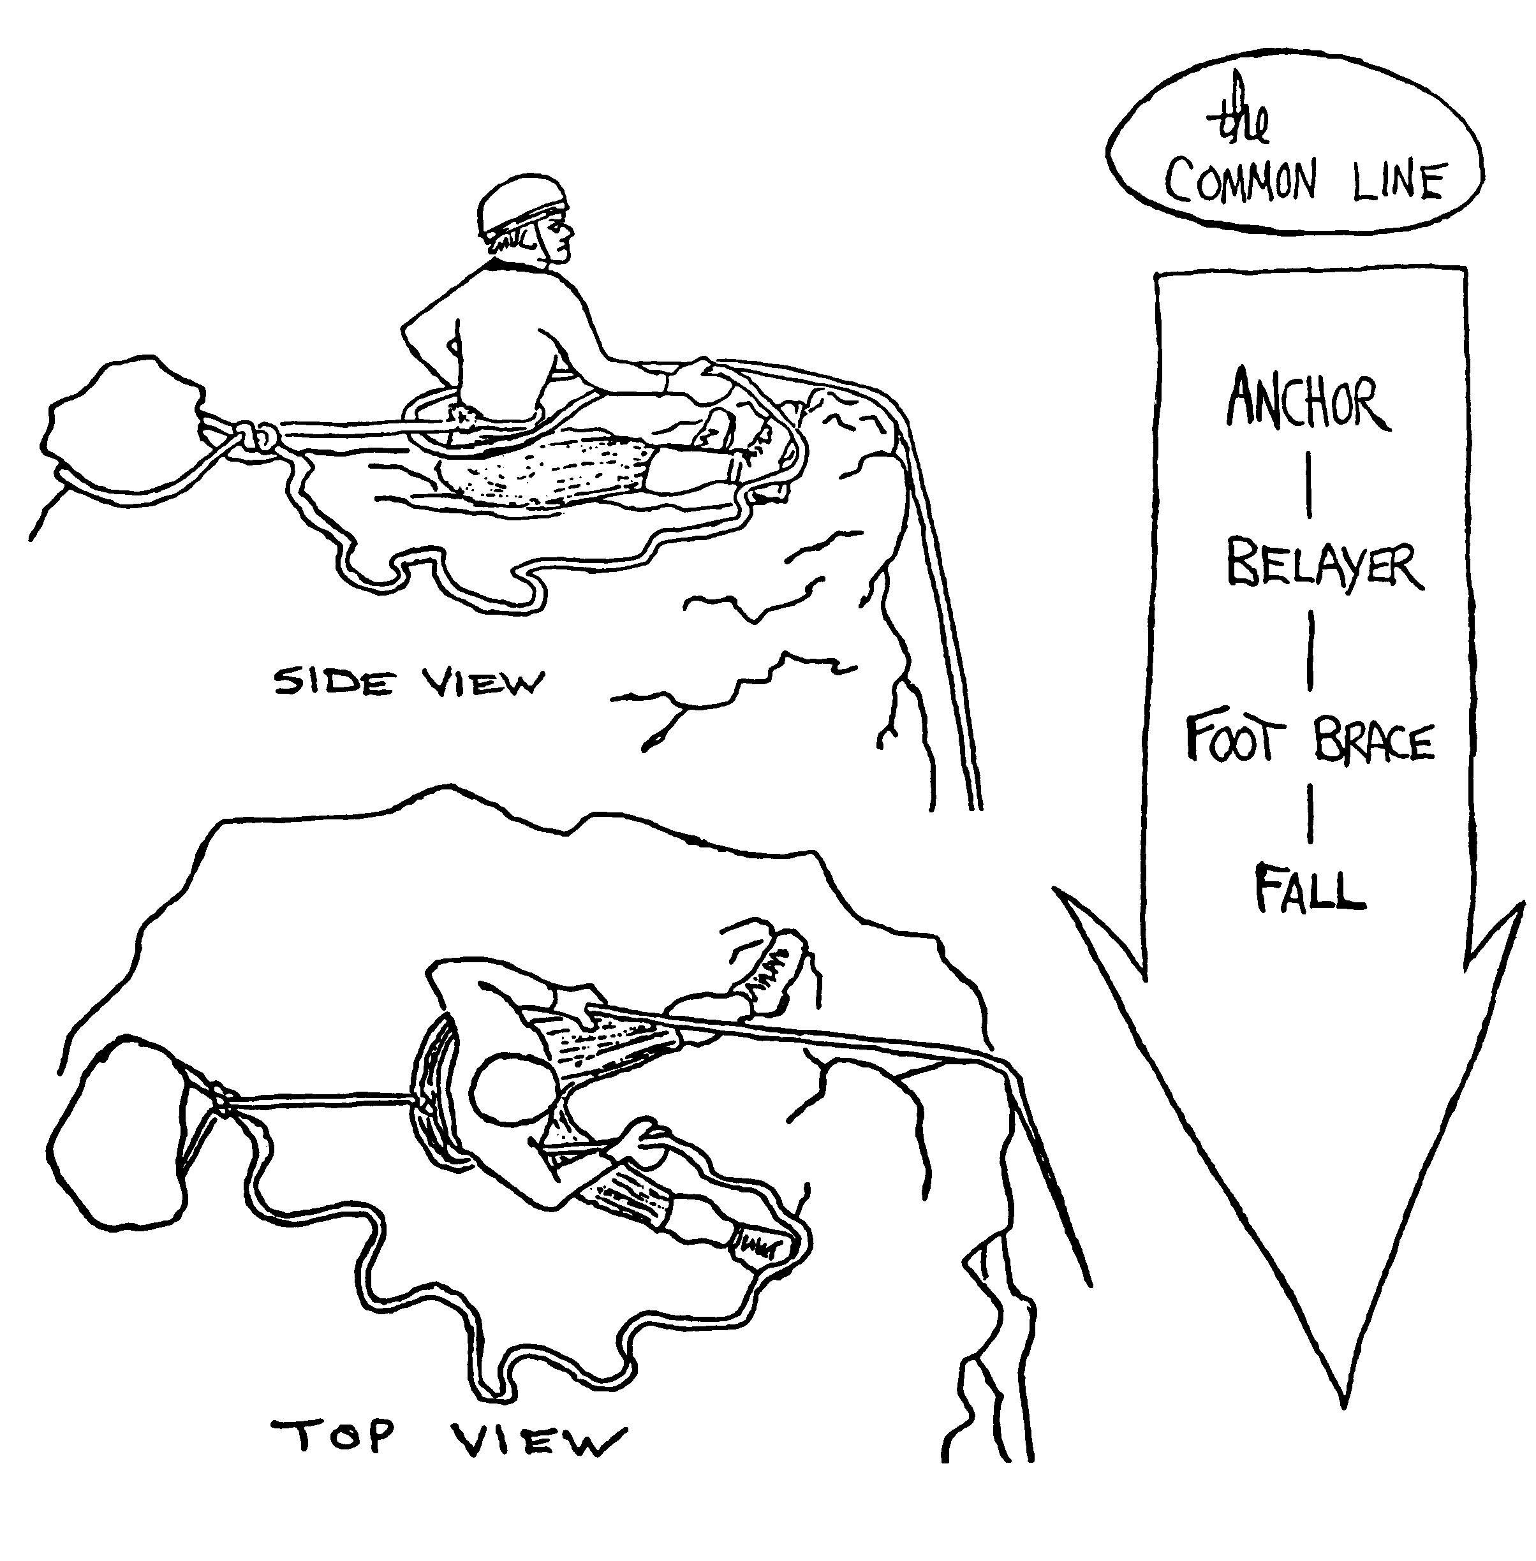

The Boot-Ax Belay

- The ice ax shaft is jammed as deep as possible into the snow with the pick pointing uphill.
- The belayer’s boot is jammed into the snow against the shaft on the downhill side of the ice ax. The second foot is planted downhill from the first.
- The uphill hand is held on the ax head while the other hand is used to apply the brake.
- The rope goes over the toe of the uphill boot, around the shaft of the ice ax, and around the boot at the ankle. The downhill (braking) hand wraps the rope around the heel to apply the brake.
- The uphill hand must do double duty when the climber approaches the belayer … the hand must take up rope slack and be prepared to hold down the ice ax. The approaching climber should move more slowly to allow for the inefficiency.
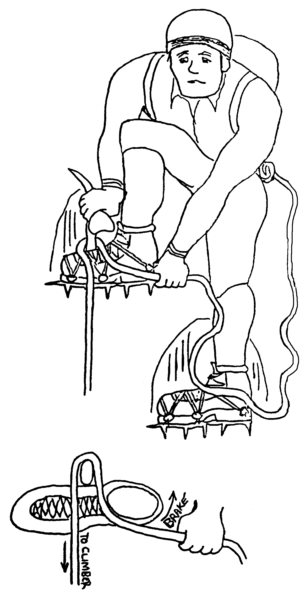

Carabiner-Ice Ax Belay
Provides the same level of security as a boot-ax belay, with easier rope handling. One nice thing about the carabiner/ice-ax belay is that the force of a fall pulls the belayer more firmly into the stance.
- Plant the ax as deeply as possible, the pick perpendicular to the fall line.
- Attach a very short sling with a girth hitch to the ax shaft at snowline and clip on a carabiner.
- Stand at a right angle to the fall line, facing the same side as the climber's route.
- Brace the ax with your uphill boot, standing atop the sling but leaving the carabiner exposed. (Keep crampons off the sling.) The rope runs from the potential direction of pull up through the carabiner and then around the back of your waist and into your uphill (braking) hand. Alternatively, the rope can run through a belay device instead of around the back.

Rappelling
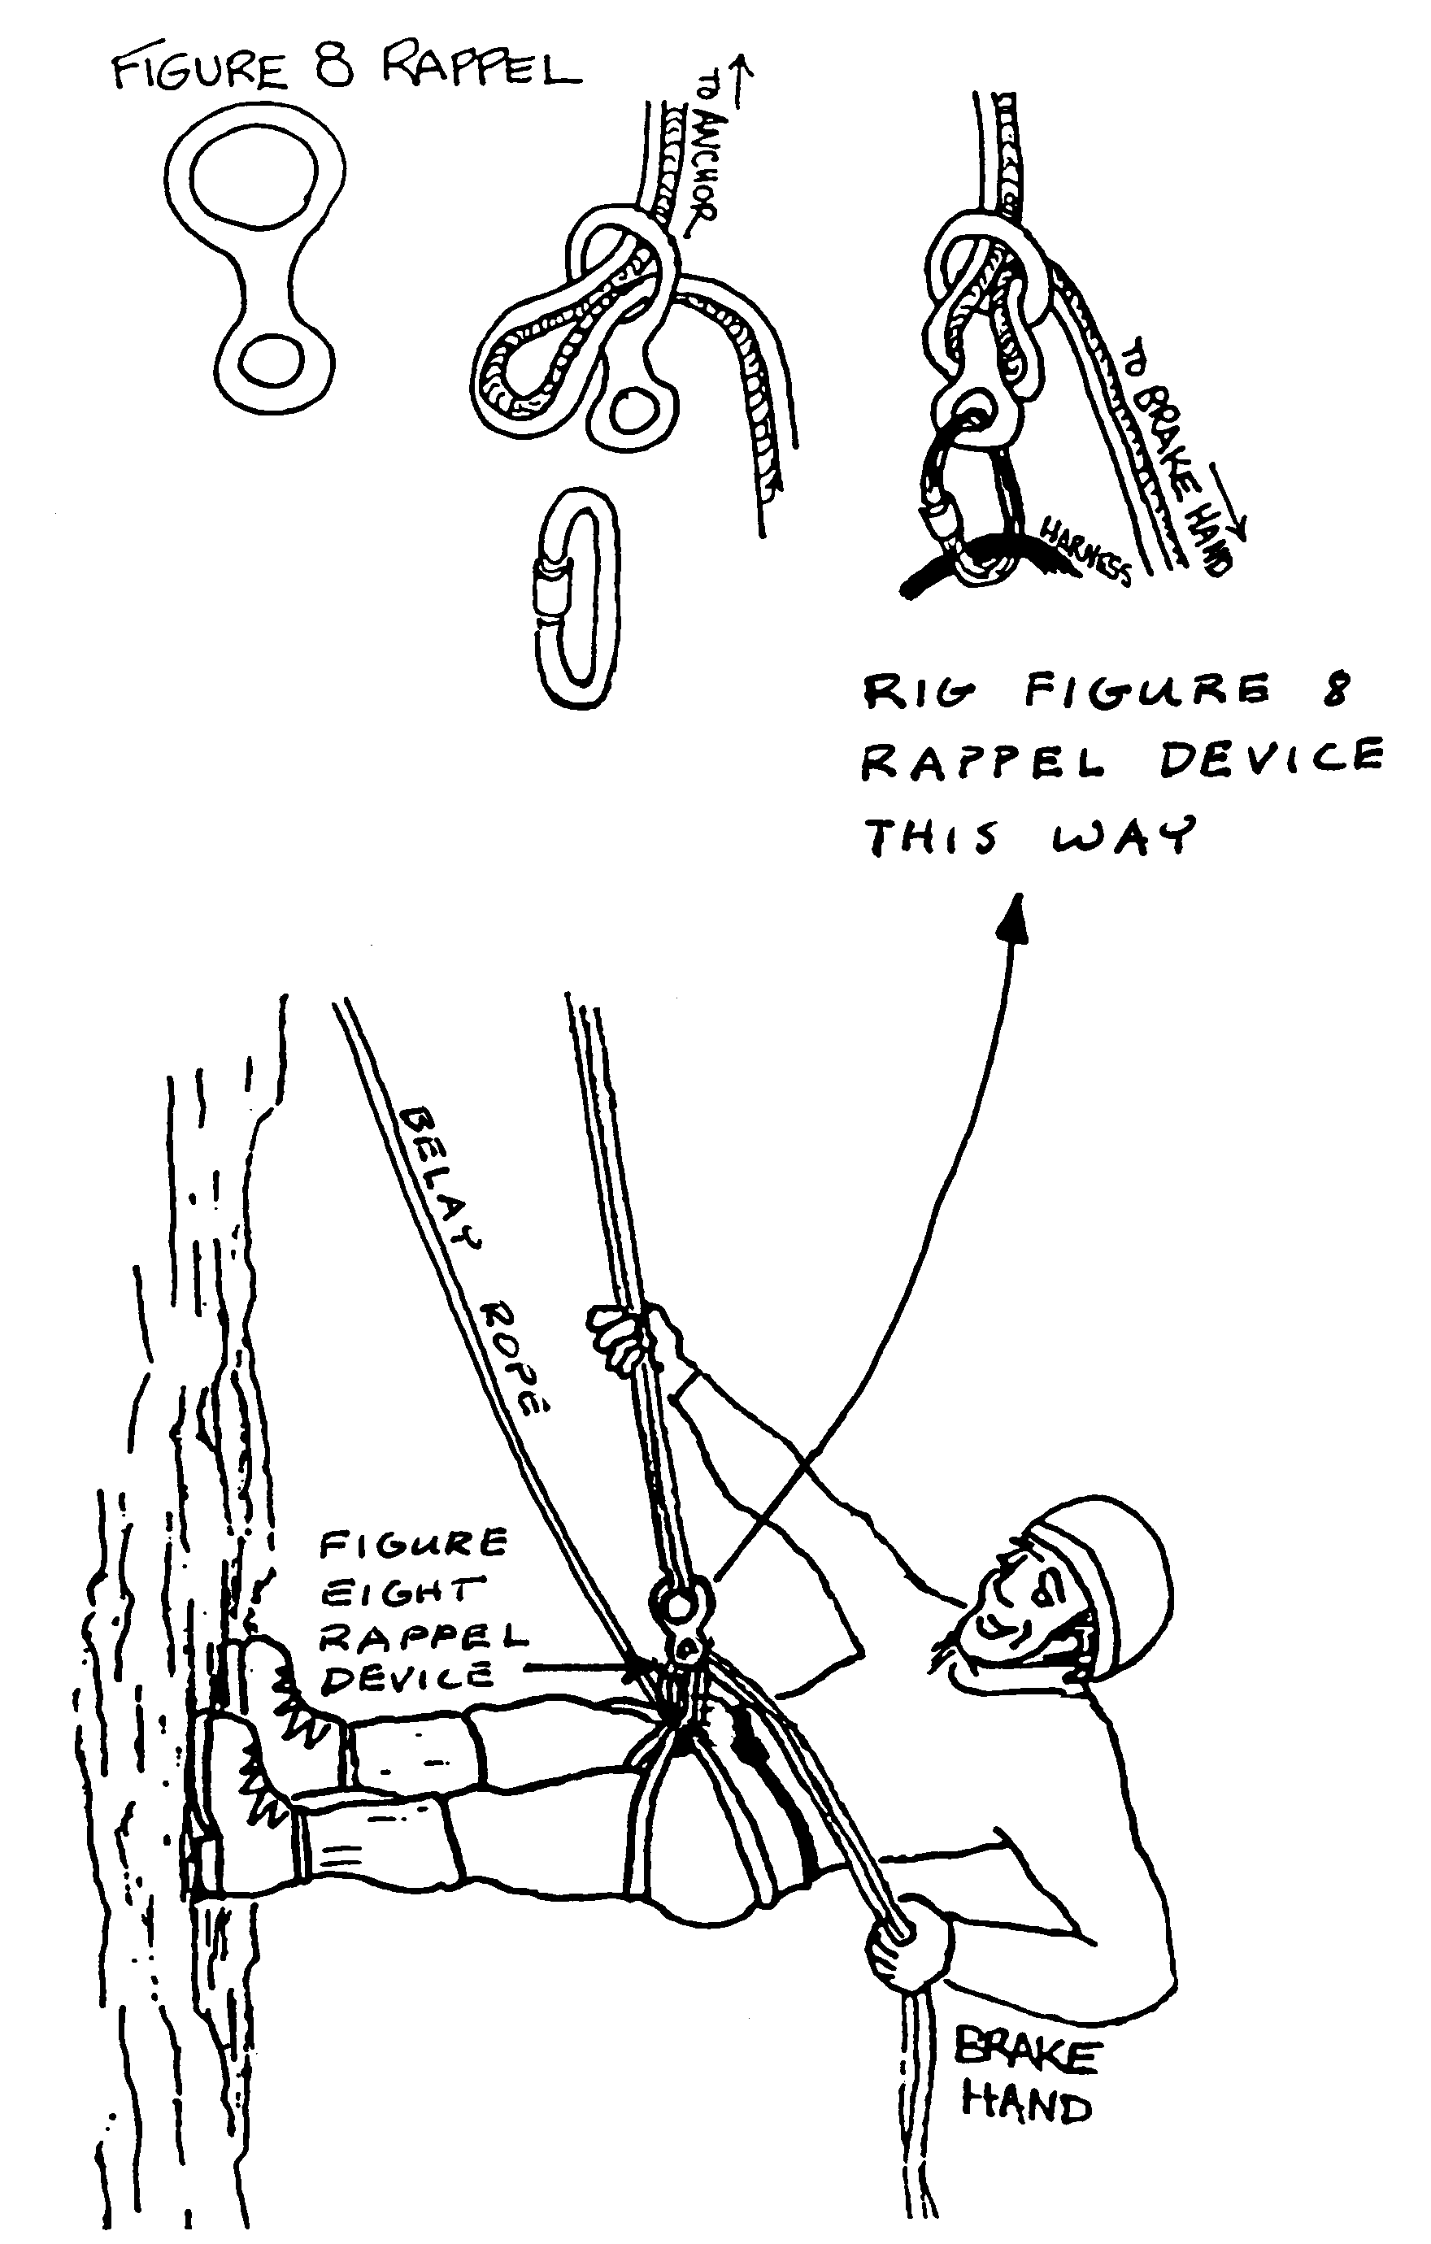

Prusiking
Prusik -- A knot that can slide freely when unweighted but won't slip when weighted.

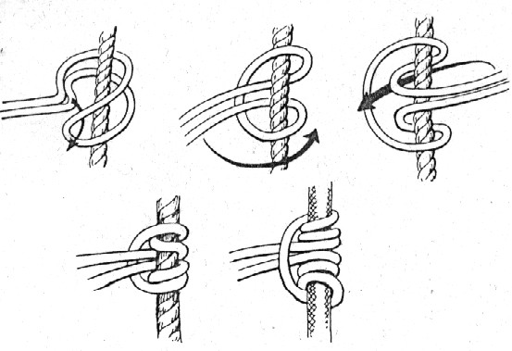
Prusik Knot
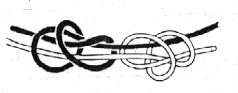Double Fisherman’s Knot

History -- The Prusik knot was invented in 1931 by Dr. Karl Prusik and was described in an Austrian mountaineering manual describing it as an ascending knot.
The Texas Prusik
This method of ascending the rope, developed by spelunkers (cavers), uses one prusik for the feet and a separate prusik for the seat (which is clipped with a locking carabiner to your seat harness). The foot prusik has two loops, one for each foot, tied so that they will adjust and cinch down on your boots.
Making Prusik Slings
- Use the most pliable Perlon cord you can find. Have the climb shop cut the cord. The waist prusik should roughly equal your height. Use the following formula for judging the length of the foot prusik (11 feet plus 2 inches for every inch you are taller than 5-0. A person who is 5-6 would need a 12-0 length of cord.
- Use a double fisherman’s knot to tie the waist prusik into a loop.
- A foot loop is tied in each end of the foot prusik. Tie an overhand stopper knot about 18 inches from each end. Tie half of a double fisherman’s knot with each end of the rope; this allows the foot loops to cinch down around a boot and the stopper knots keep the loops from cinching too tight.
- Tie an optional figure eight on a bight in the middle of each prusik making a nine-inch loop for tying each prusik to the climbing rope.
- When finished, the waist prusik should extend from belly button to eyebrows and the foot prusik should reach the belly button.
Ascending Technique
- The waist prusik is attached to rope above the foot prusik.
- Stand up in the foot loops of the foot prusik.
- Hold the rope for balance with one hand while you loosen the friction knot of the waist prusik and slide it up the rope.
- Sit down in the seat harness and weight the waist prusik.
- Loosen the friction knot of the foot prusik and move it up 18-24 inches.
- Repeat steps 2-5.
- The most difficult part of prusiking is getting over the edge at the top of the rock or ice.

Free Climbing
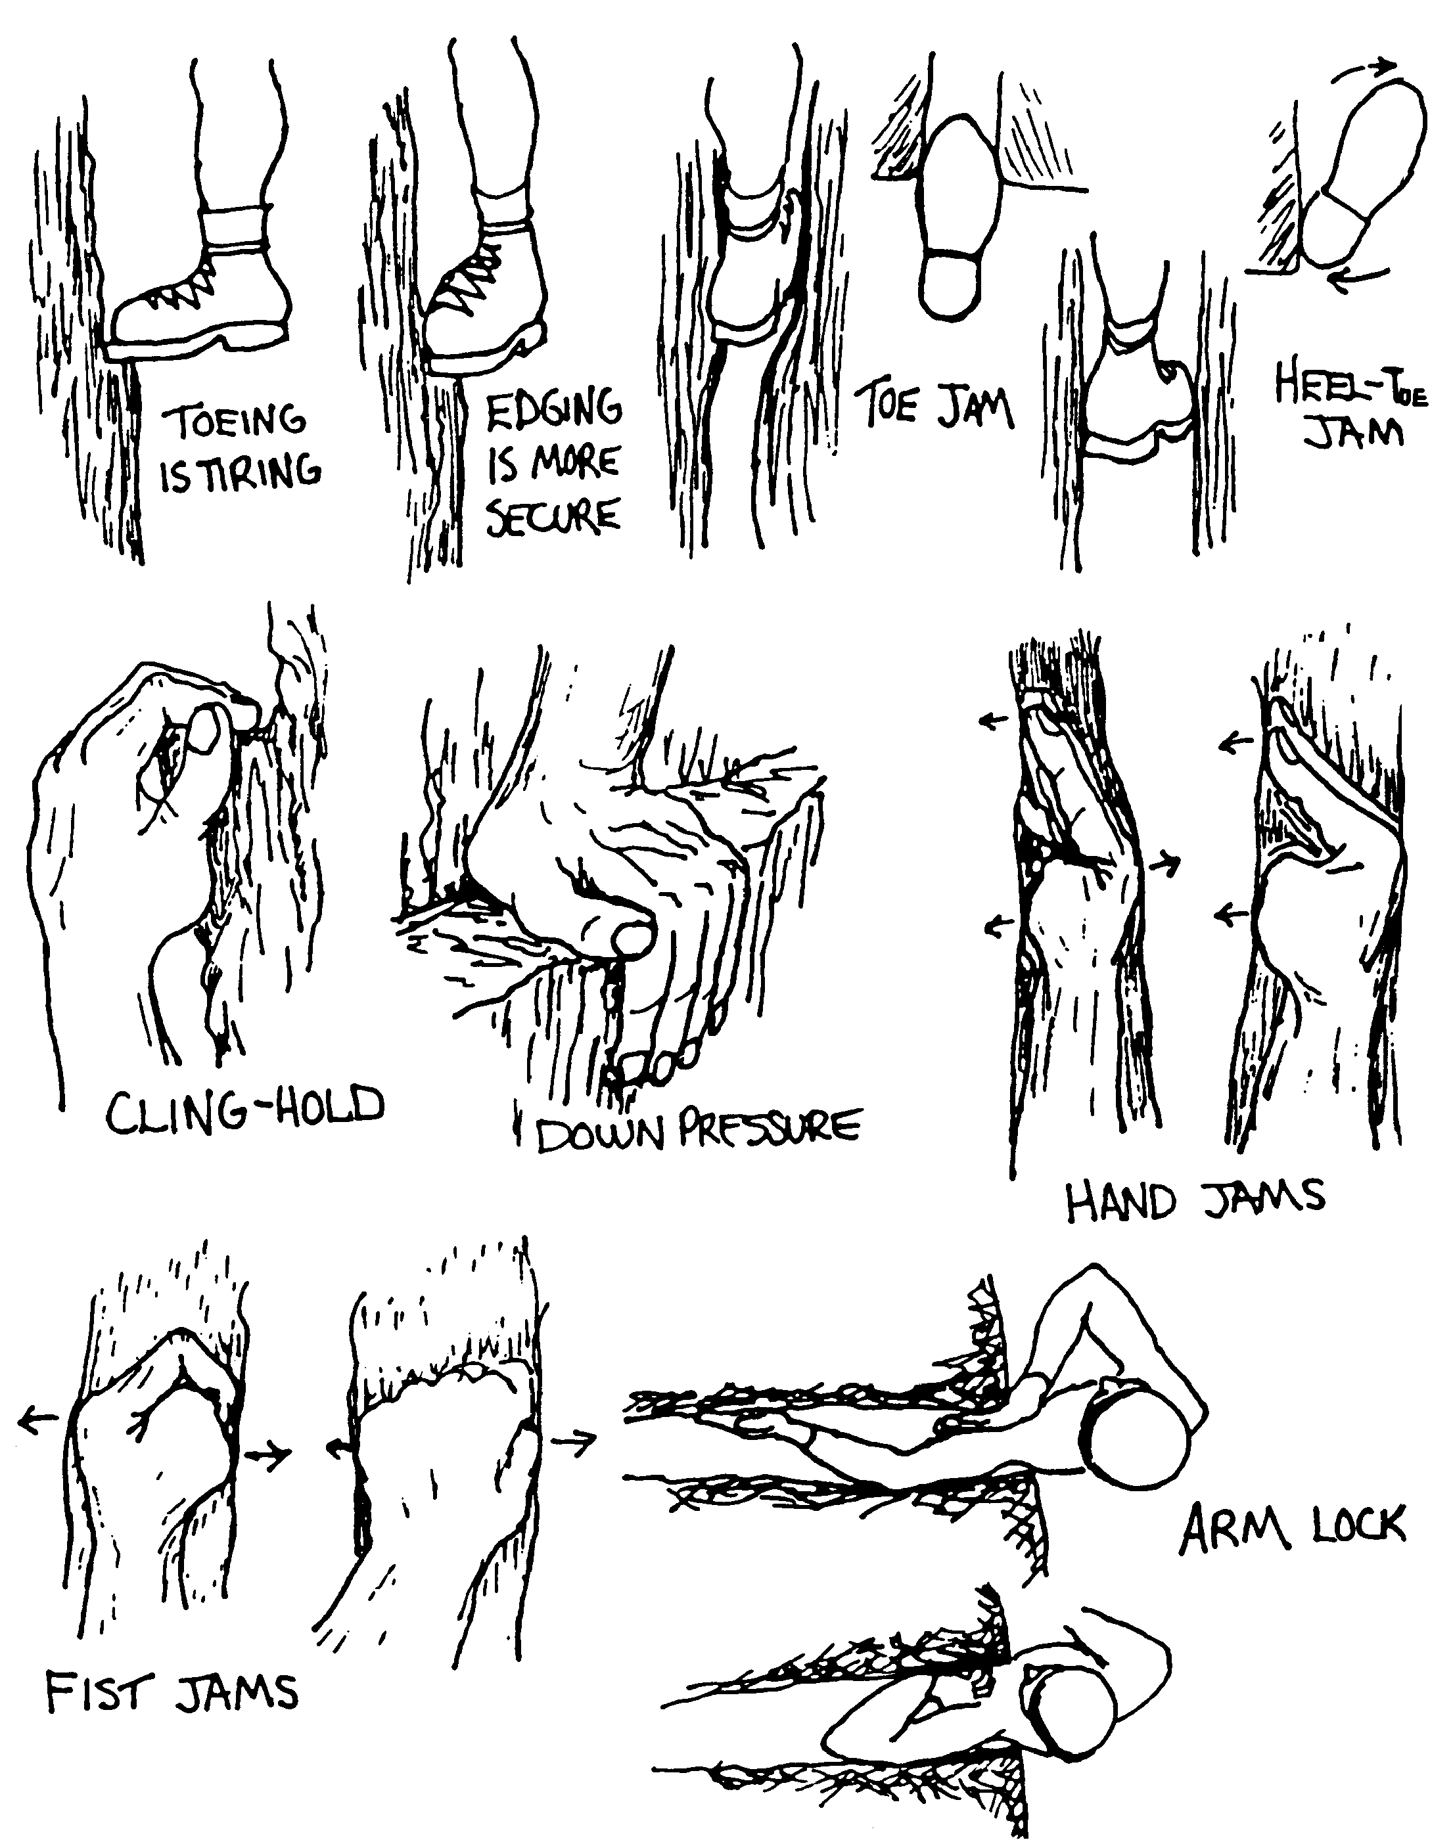

More Free Climbing

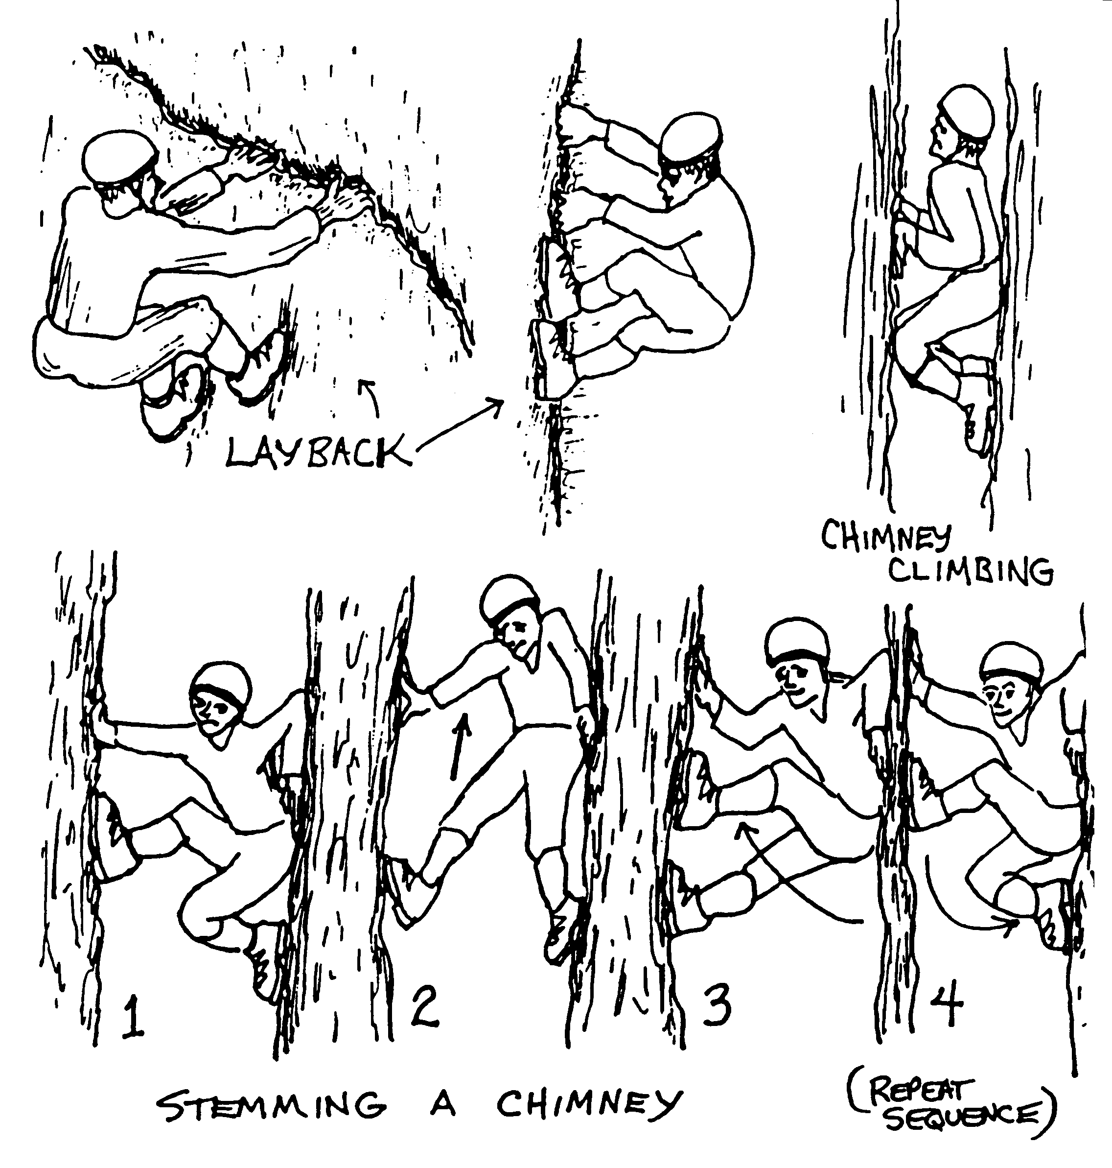

Ice Ax Self-Arrest Position

- One hand on the head of the ax with the thumb under the adze and fingers over the pick. The other hand on the shaft near the spike. Use a firm grip.
- Drive the pick into the slope near your shoulder with the shaft pulled firmly against the chest diagonally.
- Keep the chest pressing on the shaft with your back arched and legs held stiff driving your toes into the slope.
- Keep your knees up and away from the slope with your feet well spread.
- Hang on to the ax!
- This position must be attained as rapidly as possible from any fallen position. A quick self-arrest position is far better than a slow stylish one.

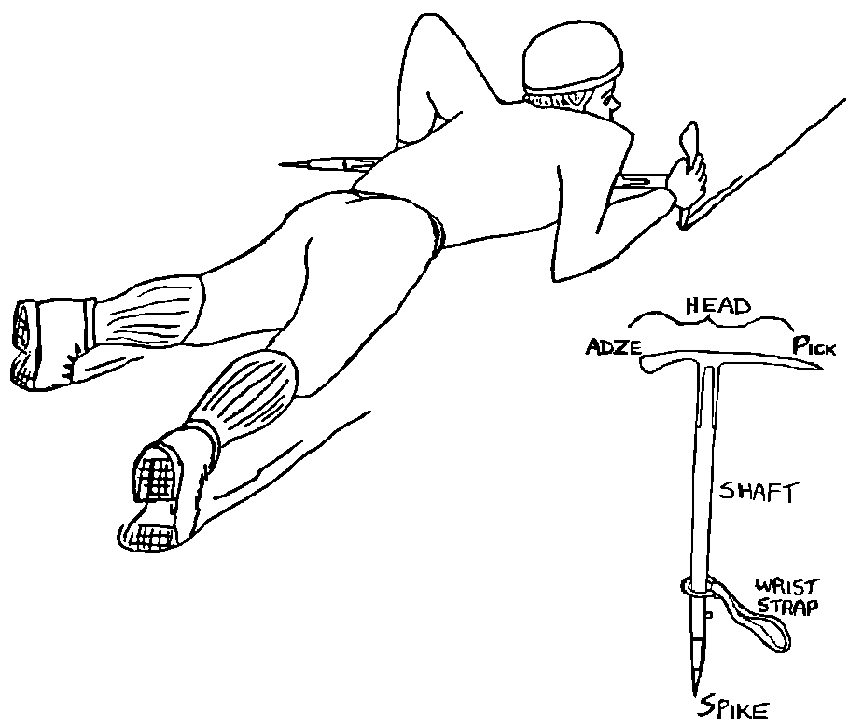

Crampons
Crampons are used on steep ice or snow slopes to minimize the need for kicking or chopping steps. Crampons should be selected to fit snuggly on the boots and be held securely by a dependable strap system. There is a “left” and a “right” crampon. Climbing with crampons requires practice. The crampon spikes are dangerous and care must be exercised not to tear clothing and flesh, or cut rope. Each step should be driven firmly into the slope. One should try to drive all spikes into the slope rather than just those on the uphill side. This may require some ankle bending. Never “glissade” with crampons.
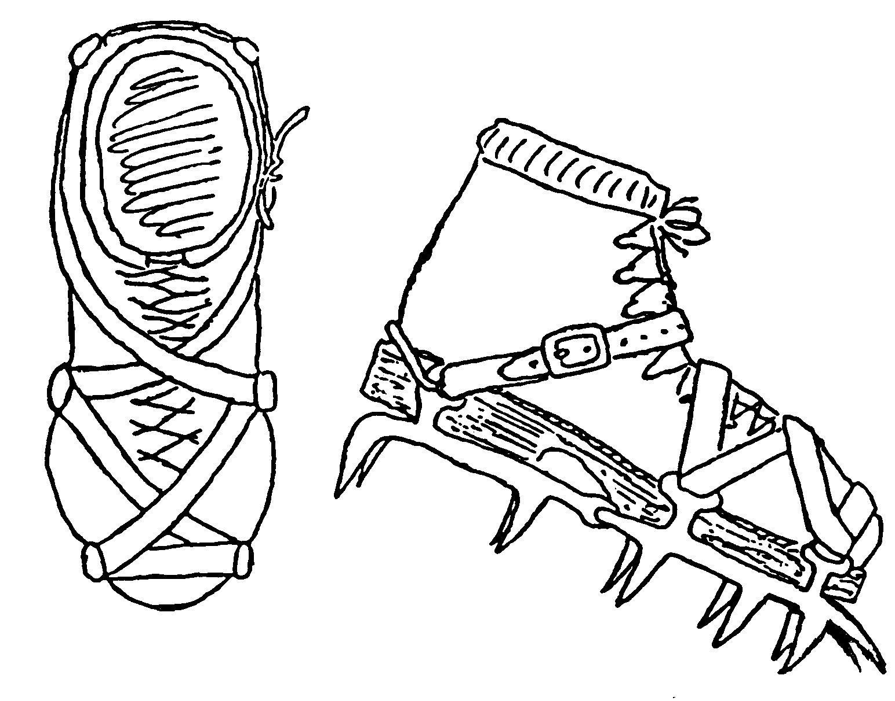

Rope Care
Modern climbing ropes are known as kernmantle ropes. They have a woven nylon sheath over a braided core. To make sure that a rope stays in prime condition there are several things to remember.
- Never step on your rope. Rock particles and other debris from your shoes could work through the sheath and begin to tear the cords.
- Never buy a used rope. You don't know what the previous owner may have done with it or why he is selling it.
- Do not expose a rope to unnecessary amounts of sunlight. UV rays are the single most damaging threat to the security of your rope. The more time it spends in direct sunlight, the faster it will deteriorate. When not in use, store your rope in a cool, dry, shady place.
- Do not expose your rope to foreign substances. Although hydrocarbon solvents such as alcohol and gasoline do not affect nylon chemically, they could make it more flammable, especially at times when the rope is exposed to large amounts of friction. Battery acids and other corrosives must be kept away from your rope at all costs.
- After even moderate use your rope will get dirty. To clean it, machine wash in cold or warm water with mild soap. Make sure to use the delicate cycle and rinse twice to make sure no soap stays in the threads. Do not put it in the dryer. Instead, hang it in a shady place or lay it out to let the water evaporate naturally. It normally takes two days to dry out completely.
- Inspect your rope frequently. To check for frays and other damage, fold the rope between your fingers and work it from one end to the other keeping watch for any sign of irregularity.
- A rope should never be kept in use for more than four years, even if used only rarely. For weekend use, retire your rope after two years. For multi-fall use, change ropes after three months of constant use or a year of part-time use. After a long, severe fall, the rope should be retired immediately.
- Do not subject the ropes to undue strain or wear. Bouncing on a rappel line, which is over a sharp edge, damages the rope.
- Do not allow kinks, twists or unnecessary knots to remain in the rope.

Coiling a Rope
Butterfly Coil
- Take both ends in one hand, then pull out two full arm's lengths of rope and drop it by your side.
- Pull out an arm's length of rope and lay it across your hand, forming a loop.
- Pull out another arm's length of rope and lay it across your palm in the opposite direction from the first one. You should now have a loop of rope hanging on either side of your hand.
- Repeat steps 2 and 3 until you reach the middle of the rope.
- Take the length of rope from step 1 and start wrapping it around the loops of rope you're holding, starting near the middle of the loops and wrapping toward your hand.
- When you have about 6' of rope left, push both ends though the hole in the top of the coil (below the hand that's holding the rope). These become your shoulder "straps".
- Put the coil on your back with a "strap" over each shoulder. Cross them over the coil behind you and tie them around your waist. You're done.
- If you don't need to carry the coil on your back, just make a few more wraps in step 5, pass a loop through the top of the coil, pass the ends through the loop and tie off.
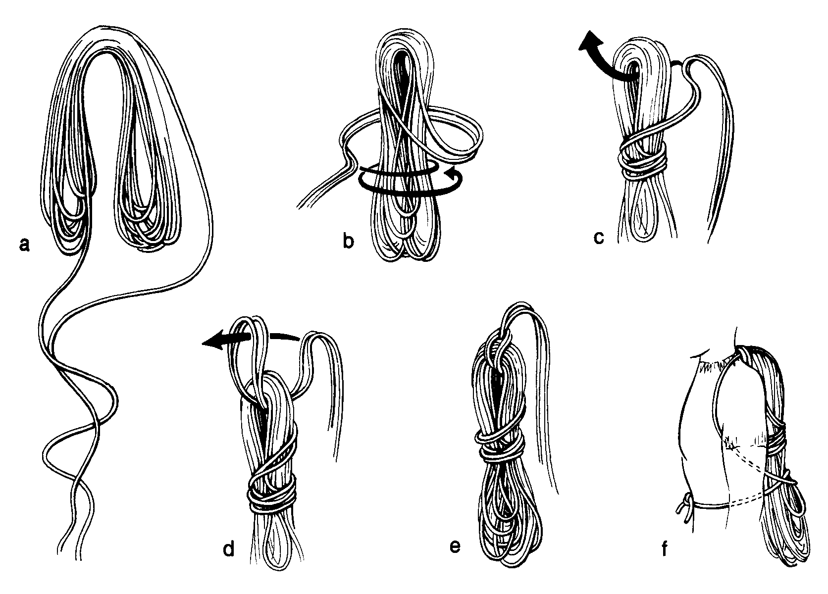

Z – Pulley Crevasse Rescue System
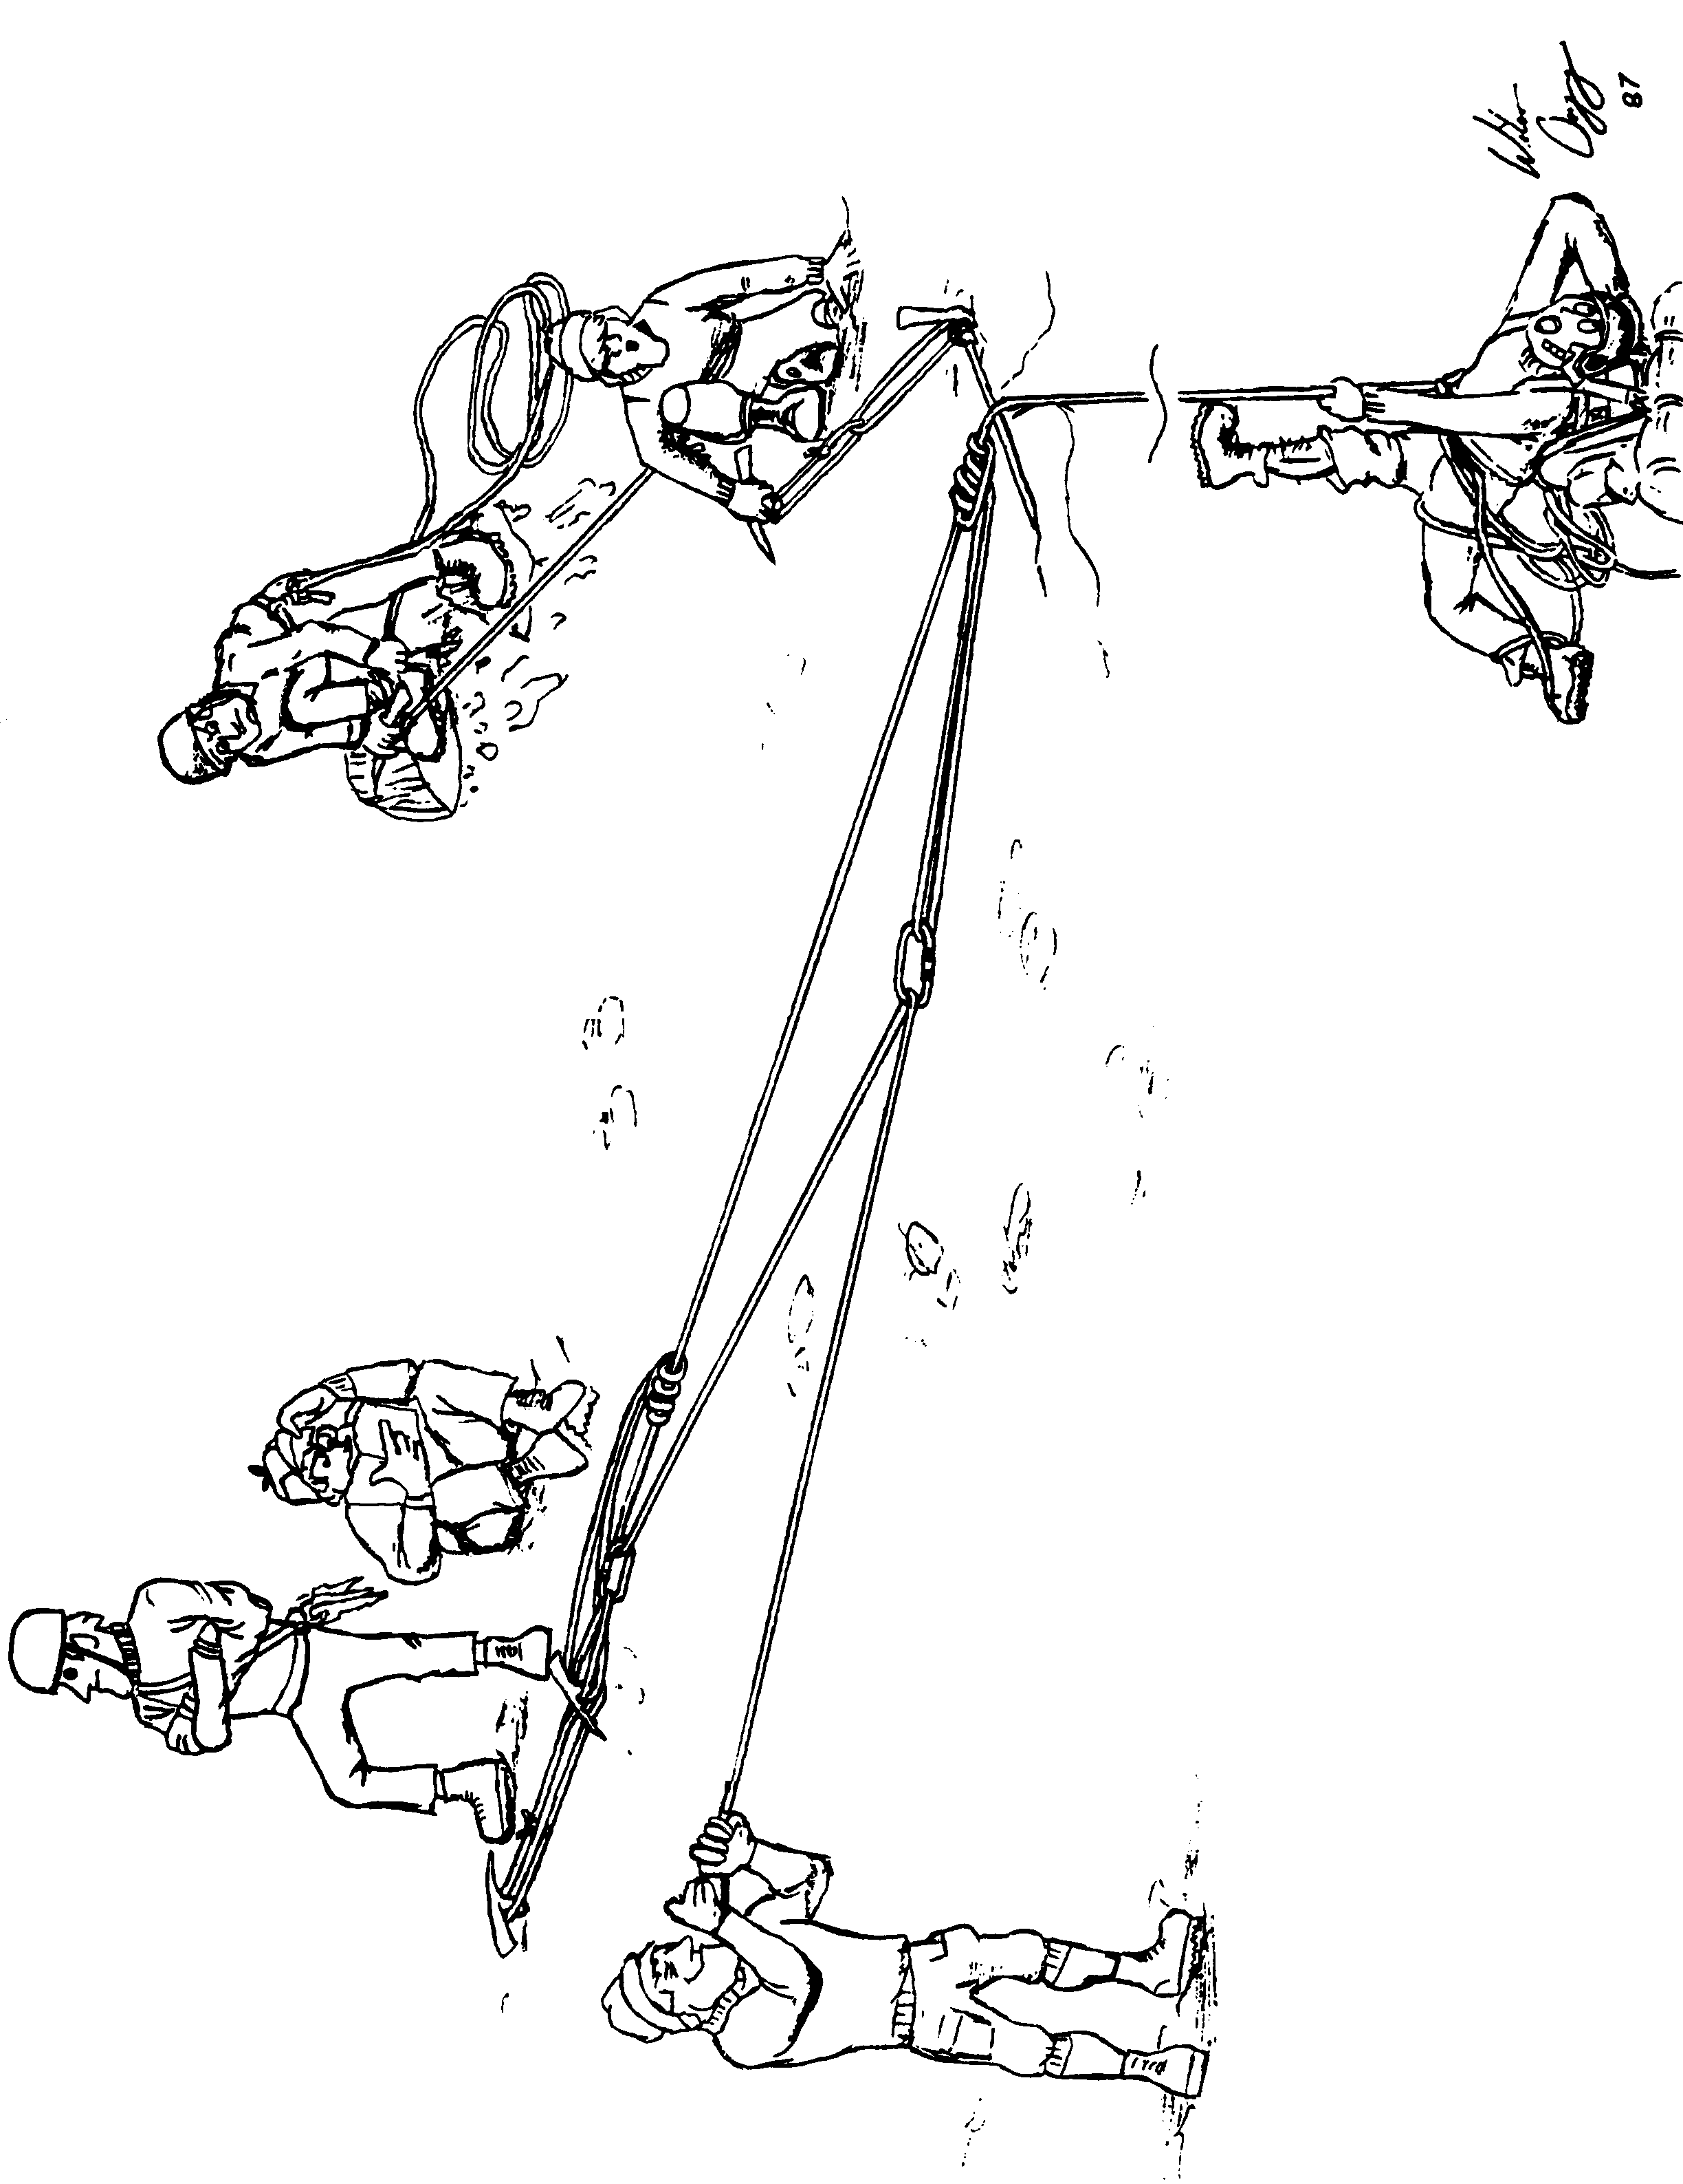

Climbing Equipment Stores
www.mountaingear.com – Equipment & Clothing for Backpacking, Rock Climbing, Backcountry Travel and Mountaineering. 800-829-2009
www.campmor.com – Mail order outdoor gear. 800-230-2153
www.sierratradingpost.com – Seconds and discontinued name brand gear at discount prices. 1-800-713-4534
www.rei.com – Recreational Equipment Inc., 7410 SW Bridgeport Rd., Tigard, OR. 503- 624-8600 also stores in Jantzen Beach, Hillsboro and Eugene. Awesome quarterly “parking lot sales”.
www.e-omc.com – Oregon Mountain Community, 2975 NE Sandy Blvd, OR. 503-227-1038
Peak Sports – Outdoor and climbing gear, 129 NW 2nd St, Corvallis, OR. 541-754-6444
www.sportsmanswarehouse.com – Sportsman’s Warehouse, 1260 Lancaster Drive SE
Salem, OR. 503-589-0800
The Mountain Shop – 628 NE Broadway St., Portland, OR 97232, 503-288-6768
Climb Max -- 612 NE Broadway, Portland, OR 97202, 503-797-1991

Notes

